UNITED STATES
SECURITIES AND EXCHANGE COMMISSION
WASHINGTON, D.C. 20549
FORM 8-K
CURRENT REPORT
PURSUANT TO SECTION 13 OR 15(d) OF THE SECURITIES EXCHANGE ACT OF 1934
September 10, 2026
(Date of earliest event reported)
LABCORP HOLDINGS INC.
(Exact Name of Registrant as Specified in its Charter)
Delaware |  |  |  |  |  | 1-11353 |  |  |  |  |  | 99-2588107
(State or other jurisdiction of Incorporation) |  |  |  |  |  | (Commission File Number) |  |  |  |  |  | (I.R.S. Employer Identification No.)

358 South Main Street
Burlington |  |  | , |  |  | North Carolina |  |  |  |  |  | 27215
(Address of principal executive offices) |  |  |  |  |  |  |  |  |  |  |  | (Zip Code)
(Registrant’s telephone number including area code) 336-229-1127
Check the appropriate box below if the Form 8-K filing is intended to simultaneously satisfy the filing obligation of the registrant under any of the following provisions:
☐ |  |  | Written communications pursuant to Rule 425 under the Securities Act (17 CFR 230.425)
☐ |  |  | Soliciting material pursuant to Rule 14a-12 under the Exchange Act (17 CFR 240.14a-12)
☐ |  |  | Pre-commencement communications pursuant to Rule 14d-2(b) under the Exchange Act (17 CFR 240.14d-2(b))
☐ |  |  | Pre-commencement communications pursuant to Rule 13e-4(c) under the Exchange Act (17 CFR 240.13e-4(c))
Securities registered pursuant to Section 12(b) of the Act:
Title of each class |  |  |  |  |  | Trading Symbol |  |  |  |  |  | Name of exchange on which registered
Common Stock, $0.10 par value |  |  |  |  |  | LH |  |  |  |  |  | New York Stock Exchange
Indicate by check mark whether the registrant is an emerging growth company as defined in Rule 405 of the Securities Act of 1933 (§230.405 of this chapter) or Rule 12b-2 of the Securities Exchange Act of 1934 (§240.12b-2 of this chapter).
Emerging growth company ☐
If an emerging growth company, indicate by check mark if the registrant has elected not to use the extended transition period for complying with any new or revised financial accounting standards provided pursuant to Section 13(a) of the Exchange Act. ☐

Item 7.01. |  |  | Regulation FD Disclosure.
Labcorp Holdings Inc. (the “Company”) (NYSE: LH), a global leader of innovative and comprehensive laboratory services, today hosted its 2026 Investor Day (“Investor Day”), where the company provided an in-depth review of its growth strategy, innovation roadmap, and long-term financial outlook.
In connection with Investor Day, the Company issued a press release that, among other things, discussed its business strategy, reaffirmed its full-year 2026 guidance, and provided its long-term financial outlook through 2029. A copy of the press release is furnished as Exhibit 99.1 hereto and incorporated by reference herein.
The Investor Day presentation used by members of the Company’s executive leadership team, which includes information regarding the matters discussed by the Company at its Investor Day and in the press release, has been posted on the Labcorp Investor Relations website at ir.labcorp.com. In addition, a copy of this presentation is furnished as Exhibit 99.2 hereto and incorporated by reference herein.
The information in this Current Report on Form 8-K (including the exhibits attached hereto) shall not be deemed “filed” for the purposes of Section 18 of the Securities Exchange Act of 1934, as amended (the “Exchange Act”), or otherwise subject to the liabilities of that Section. The information in this Current Report on Form 8-K (including the exhibits attached hereto) shall not be deemed incorporated by reference into any filing or other document under the Securities Act of 1933, as amended, or the Exchange Act, except as shall be expressly set forth by specific reference in such filing or document.
Item 9.01. |  |  | Financial Statements and Exhibits.
Exhibit |  |  | Exhibit Name
Exhibit 99.1 |  |  | Press Release dated September 10, 2026 issued by Labcorp Holdings Inc.
Exhibit 99.2 |  |  | Investor Day Presentation, dated September 10, 2026
Exhibit 104 |  |  | Cover Page Interactive Data File (embedded within the Inline XBRL document)

SIGNATURE

Pursuant to the requirements of the Securities Exchange Act of 1934, the registrant has duly caused this report to be signed on its behalf by the undersigned hereunto duly authorized.

LABCORP HOLDINGS INC.
Registrant

Date: September 10, 2026 |  |  | By: |  |  | /s/KATHRYN W. KYLE
 |  |  |  |  |  | Kathryn W. Kyle
 |  |  |  |  |  | Executive Vice President, Chief Legal Officer and Corporate Secretary



Media |  |  |  |  |  | Investors
Racquel White |  |  |  |  |  | Dewey Steadman
Media@Labcorp.com |  |  |  |  |  | Investor@Labcorp.com

Labcorp Highlights Strategic Priorities Driving Durable Growth
and Shareholder Value at 2026 Investor Day

•Reaffirms full-year 2026 guidance
•Provides long-term outlook through 2029, with compound annual revenue growth of 5% to 8% and compound annual adjusted earnings per share (EPS) growth of 8.5% to 11.5%
•Outlines strategic growth priorities driven by a differentiated platform powered by science, technology and global scale
•Presents long-term value creation framework driven by sustainable growth, strong cash flow generation and disciplined capital deployment

BURLINGTON, N.C., (Sept. 10, 2026) — Labcorp (NYSE: LH), a global leader of innovative and comprehensive laboratory services, today will host its 2026 Investor Day at 9 a.m. ET, where the company will provide an in-depth review of its growth strategy, innovation roadmap and long-term financial outlook. The event will highlight Labcorp's unique position at the intersection of diagnostics, biopharma, science and technology and how the company is creating long-term value for customers and shareholders.

“Labcorp has never been more relevant than it is today,” said Adam Schechter, Chairman and CEO of Labcorp. “The healthcare landscape is being transformed by scientific innovation, personalized medicine and consumer-directed care, and the strengths of Labcorp will help shape the future of healthcare. Labcorp's growth strategy supports our expectation for above-market performance and underpins our long-term outlook through 2029 of compound annual growth of 5% to 8% in revenue and 8.5% to 11.5% in adjusted earnings per share.”

Strategic Priorities Focused on High-Growth Areas
At Investor Day, Labcorp will highlight the four strategic priorities that are driving its next phase of growth and strengthening its leadership position across the healthcare ecosystem. These priorities are:

•Leading in specialty testing through continued innovation in oncology, neurology, autoimmune diseases and women’s health.
•Being a partner of choice for health systems and leading pharmaceutical companies through differentiated scientific and operational capabilities.
•Driving personalized health solutions using science and insights to help develop therapies, inform therapy selection and deliver tailored experiences at scale.
•Shaping the company’s future through advanced technology, including artificial intelligence and robotics.

Long-Term Financial Outlook
In addition to reaffirming its 2026 guidance, Labcorp will discuss its outlook through 2029. Specifically, the company expects to achieve:
•Compound annual revenue growth between 5% and 8%
•Adjusted operating margin expansion between 75 and 150 basis points by the end of 2029
•Compound annual adjusted EPS growth between 8.5% and 11.5%
•Compound annual free cash flow growth in line with adjusted earnings growth

“Our confidence in this outlook is grounded in a proven record of delivering on our commitments and a disciplined value creation framework that converts growth into earnings, cash flow and shareholder returns,” said Julia Wang, Executive Vice President and Chief Financial Officer.

Webcast
A live webcast of the event will be available through the Labcorp Investor Relations website beginning at 9 a.m. ET. A replay of the webcast and supporting materials will be available after the conclusion of the event.

Guidance for 2026
Labcorp is affirming 2026 full-year guidance, last updated on July 30, 2026. The following guidance assumes foreign exchange rates effective as of June 30, 2026. Enterprise level guidance includes the estimated impact from currently anticipated capital allocation, including acquisitions, share repurchases, and dividends.

 |  |  |  |  |  | 2026 Guidance
 |  |  |  |  |  | Low |  |  |  |  |  | High
Revenue
Labcorp Enterprise (1) (2) |  |  |  |  |  | $14,710 |  |  |  |  |  | $14,827
Growth (3) |  |  |  |  |  | 5.4% |  |  |  |  |  | 6.3%
Diagnostics Laboratories |  |  |  |  |  | $11,450 |  |  |  |  |  | $11,532
Growth (3) |  |  |  |  |  | 5.3% |  |  |  |  |  | 6.0%
Biopharma Laboratory Services (4) |  |  |  |  |  | $3,269 |  |  |  |  |  | $3,300
Growth (3) |  |  |  |  |  | 5.5% |  |  |  |  |  | 6.5%
Adjusted EPS |  |  |  |  |  | $18.10 |  |  |  |  |  | $18.55
Free Cash Flow |  |  |  |  |  | $1,240 |  |  |  |  |  | $1,360

(1) 2026 Enterprise guidance includes an impact from foreign currency translation of 0.4%.
(2) Enterprise level revenue is presented net of intercompany transaction eliminations.
(3) Growth based on 2025 Enterprise revenue of $13,952 million, Diagnostics Laboratories revenue of $10,876 million, and Biopharma Laboratory Services revenue of $3,098 million.
(4) 2026 Biopharma Laboratory Services guidance includes an impact from foreign currency translation of 1.5%.

About Labcorp
Labcorp (NYSE: LH) is a global leader of innovative and comprehensive laboratory services that helps doctors, hospitals, pharmaceutical companies, researchers and patients make clear and confident decisions. We provide insights and advance science to improve health and improve lives through our unparalleled diagnostics and drug development laboratory capabilities. The company's nearly 71,000 employees serve clients in approximately 100 countries, provided support for more than 85% of the new drugs and therapeutic products approved by the FDA in 2025 and performed more than 750 million tests for patients around the world. Learn more at www.labcorp.com.

Use of Adjusted Measures
The company has provided in this press release “adjusted” financial information that has not been prepared in accordance with GAAP, including adjusted EPS (or adjusted net income per share), adjusted operating margin, and free cash flow. Moreover, the company is not able to provide reconciliations of these adjusted measures on a forward-looking basis because it is unable to predict, without unreasonable effort, certain components thereof. As such, any associated estimate and its impact on these measures could vary materially, and the company cannot address the probable significance of unavailable information. The company believes these adjusted measures are useful to investors as a supplement to, but not as a substitute for, GAAP measures, in evaluating the company’s operational performance. The company further believes that the use of these non-GAAP financial measures provides an additional tool for investors in evaluating operating results and trends, and growth and shareholder returns, as well as in comparing the company’s financial results with the financial results of other companies.

Non-GAAP adjusted measures should not be considered as an alternative to the corresponding measures prepared in accordance with GAAP, and these adjusted measures may be different from and not directly comparable to the measures presented by other companies.

Cautionary Statement Regarding Forward-Looking Statements
This press release contains forward-looking statements, including, but not limited to, statements with respect to (i) the estimated 2026 guidance, the long-term financial outlook, and the long-term capital deployment strategy, and related assumptions of each, (ii) the impact of various factors on operating and financial results, including global economic and market conditions, on the company's businesses, operating results, cash flows, and/or financial condition, (iii) current and future offerings, capabilities, and business strategies, including those related to high-growth specialty areas, (iv) expected savings, synergies and other benefits to the company, customers or patients from acquisitions and other transactions, partnerships, company initiatives and investments, (v) the use of technology, including the use of artificial intelligence (AI), and expected operational efficiencies, revenue growth, impacts on customer and patient experience and access, and other benefits from the use of such technologies, and (vi) opportunities for future growth.

Each of the forward-looking statements is subject to change based on various important factors, many of which are beyond the company's control, including without limitation: (i) the failure to receive tax-free treatment with respect to the spin-off of the company’s former Clinical Development and Commercialization Services business for U.S. federal income purposes; (ii) the impact of spin-off related items; (iii) personnel costs and potential difficulties with employee relations and retention; (iv) the trading price of the company's stock, competitive actions and other unforeseen changes and general uncertainties in the marketplace; (v) the impact of changes to existing or adoption of new laws and regulations applicable to the company, including healthcare reform, or changes to the interpretation and application of such laws and regulations; (vi) customer preferences and purchasing decisions, including changes in payer regulations or policies; (vii) adverse actions of governmental and third-party payers; (viii) changes in testing guidelines or recommendations; (ix) the impact of global geopolitical events; (x) the effect of public opinion on the company's reputation; (xi) adverse results in material litigation matters; (xii) failure to maintain or develop customer relationships; (xiii) the company's ability to develop or acquire new products and adapt to technological changes; (xiv) failures of, or adverse events relating to, the company’s information technology systems, programs, or processes or the company’s data security; (xv) the impact of potential losses under repurchase agreements; (xvi) adverse weather conditions; (xvii) the number of revenue days in a financial period; (xviii) inflation; (xix) increased competition; and (xx) the effect of exchange rate fluctuations. These factors, in some cases, have affected and in the future (together with other factors) could affect the company's ability to implement the company's business strategy, and actual results could differ materially from those suggested by these forward-looking statements. As a result, readers are cautioned not to place undue reliance on any of the forward-looking statements.

The company has no obligation to provide any updates to these forward-looking statements even if its expectations change. All forward-looking statements are expressly qualified in their entirety by this cautionary statement. Further information on potential factors, risks and uncertainties that could affect operating and financial results is included in the company's most recent Annual Report on Form 10-K and subsequent Forms 10-Q, including in each case under the heading RISK FACTORS, and in the company's other filings with the SEC. The information in this press release should be read in conjunction with a review of the company's filings with the SEC including the information in the company's most recent Annual Report on Form 10-K, and subsequent Forms 10-Q, under the heading “MANAGEMENT'S DISCUSSION AND ANALYSIS OF FINANCIAL CONDITION AND RESULTS OF OPERATIONS”.


©2026 Labcorp. All rights reserved.

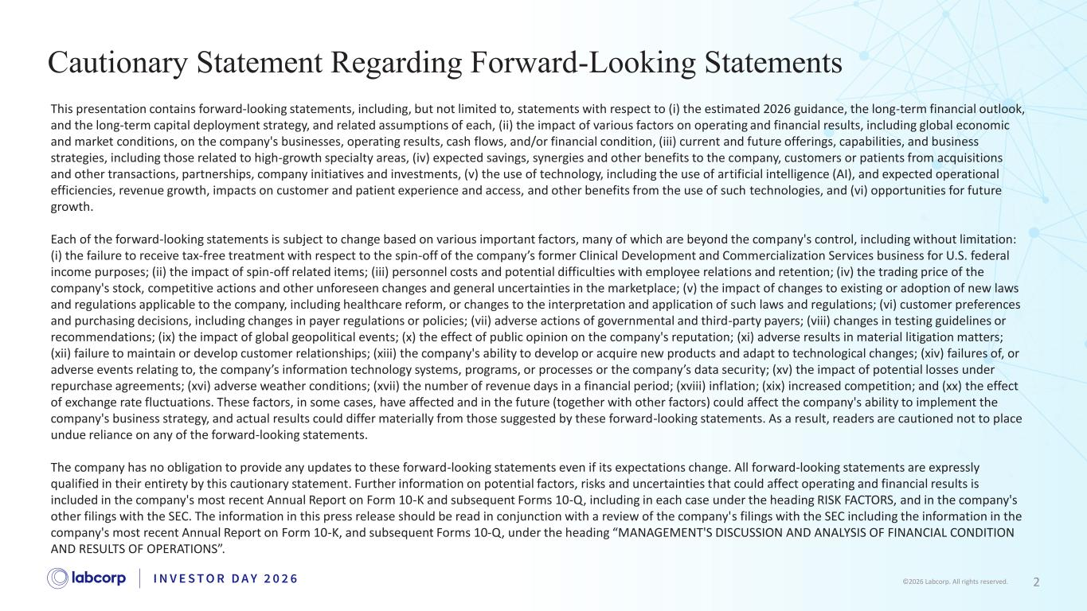
2©2026 Labcorp. All rights reserved. Cautionary Statement Regarding Forward-Looking Statements This presentation contains forward-looking statements, including, but not limited to, statements with respect to (i) the estimated 2026 guidance, the long-term financial outlook, and the long-term capital deployment strategy, and related assumptions of each, (ii) the impact of various factors on operating and financial results, including global economic and market conditions, on the company's businesses, operating results, cash flows, and/or financial condition, (iii) current and future offerings, capabilities, and business strategies, including those related to high-growth specialty areas, (iv) expected savings, synergies and other benefits to the company, customers or patients from acquisitions and other transactions, partnerships, company initiatives and investments, (v) the use of technology, including the use of artificial intelligence (AI), and expected operational efficiencies, revenue growth, impacts on customer and patient experience and access, and other benefits from the use of such technologies, and (vi) opportunities for future growth. Each of the forward-looking statements is subject to change based on various important factors, many of which are beyond the company's control, including without limitation: (i) the failure to receive tax-free treatment with respect to the spin-off of the company’s former Clinical Development and Commercialization Services business for U.S. federal income purposes; (ii) the impact of spin-off related items; (iii) personnel costs and potential difficulties with employee relations and retention; (iv) the trading price of the company's stock, competitive actions and other unforeseen changes and general uncertainties in the marketplace; (v) the impact of changes to existing or adoption of new laws and regulations applicable to the company, including healthcare reform, or changes to the interpretation and application of such laws and regulations; (vi) customer preferences and purchasing decisions, including changes in payer regulations or policies; (vii) adverse actions of governmental and third-party payers; (viii) changes in testing guidelines or recommendations; (ix) the impact of global geopolitical events; (x) the effect of public opinion on the company's reputation; (xi) adverse results in material litigation matters; (xii) failure to maintain or develop customer relationships; (xiii) the company's ability to develop or acquire new products and adapt to technological changes; (xiv) failures of, or adverse events relating to, the company’s information technology systems, programs, or processes or the company’s data security; (xv) the impact of potential losses under repurchase agreements; (xvi) adverse weather conditions; (xvii) the number of revenue days in a financial period; (xviii) inflation; (xix) increased competition; and (xx) the effect of exchange rate fluctuations. These factors, in some cases, have affected and in the future (together with other factors) could affect the company's ability to implement the company's business strategy, and actual results could differ materially from those suggested by these forward-looking statements. As a result, readers are cautioned not to place undue reliance on any of the forward-looking statements. The company has no obligation to provide any updates to these forward-looking statements even if its expectations change. All forward-looking statements are expressly qualified in their entirety by this cautionary statement. Further information on potential factors, risks and uncertainties that could affect operating and financial results is included in the company's most recent Annual Report on Form 10-K and subsequent Forms 10-Q, including in each case under the heading RISK FACTORS, and in the company's other filings with the SEC. The information in this press release should be read in conjunction with a review of the company's filings with the SEC including the information in the company's most recent Annual Report on Form 10-K, and subsequent Forms 10-Q, under the heading “MANAGEMENT'S DISCUSSION AND ANALYSIS OF FINANCIAL CONDITION AND RESULTS OF OPERATIONS”.

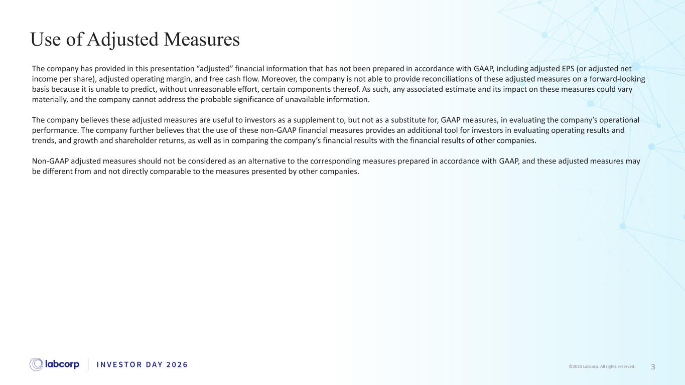
3©2026 Labcorp. All rights reserved. Use of Adjusted Measures The company has provided in this presentation “adjusted” financial information that has not been prepared in accordance with GAAP, including adjusted EPS (or adjusted net income per share), adjusted operating margin, and free cash flow. Moreover, the company is not able to provide reconciliations of these adjusted measures on a forward-looking basis because it is unable to predict, without unreasonable effort, certain components thereof. As such, any associated estimate and its impact on these measures could vary materially, and the company cannot address the probable significance of unavailable information. The company believes these adjusted measures are useful to investors as a supplement to, but not as a substitute for, GAAP measures, in evaluating the company’s operational performance. The company further believes that the use of these non-GAAP financial measures provides an additional tool for investors in evaluating operating results and trends, and growth and shareholder returns, as well as in comparing the company’s financial results with the financial results of other companies. Non-GAAP adjusted measures should not be considered as an alternative to the corresponding measures prepared in accordance with GAAP, and these adjusted measures may be different from and not directly comparable to the measures presented by other companies.

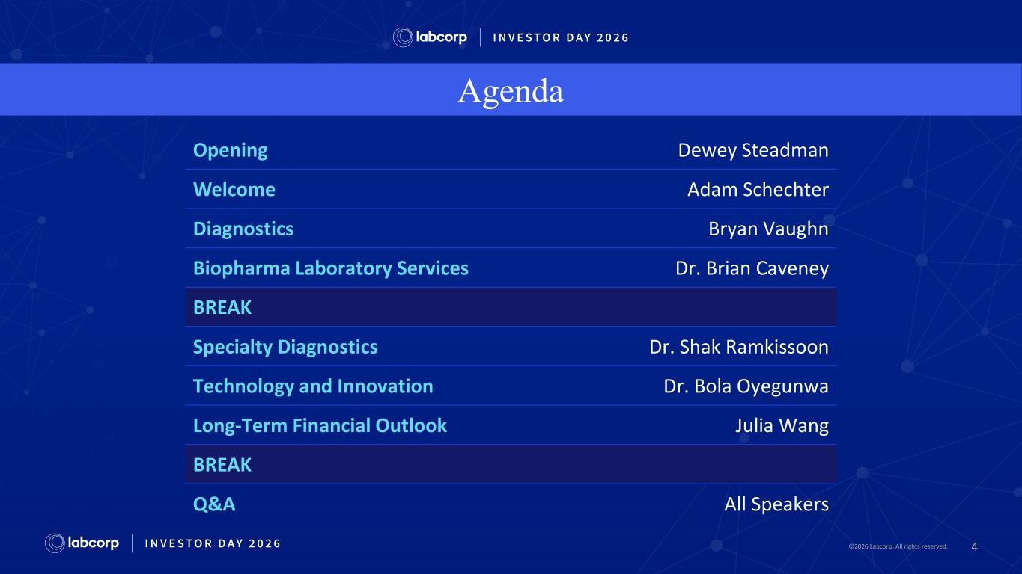
4©2026 Labcorp. All rights reserved.2026 Labcorp. All rights reserved. Agenda Opening Dewey Steadman Welcome Adam Schechter Diagnostics Bryan Vaughn Biopharma Laboratory Services Dr. Brian Caveney BREAK Specialty Diagnostics Dr. Shak Ramkissoon Technology and Innovation Dr. Bola Oyegunwa Long-Term Financial Outlook Julia Wang BREAK Q&A All Speakers

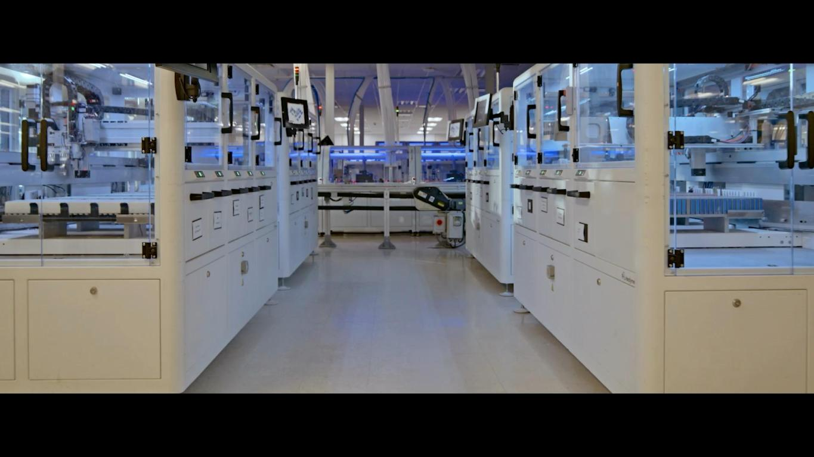
5©2026 Labcorp. All rights reserved.2026 Labcorp. All rights reserved.


6©2026 Labcorp. All rights reserved. Adam Schechter Chairman and Chief Executive Officer Welcome

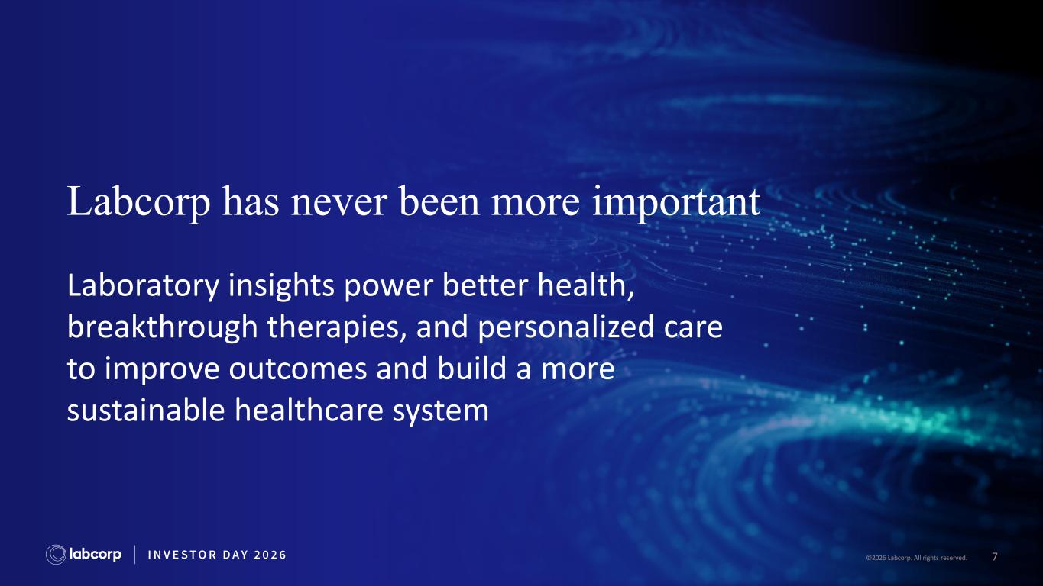
7©2026 Labcorp. All rights reserved. Labcorp has never been more important Laboratory insights power better health, breakthrough therapies, and personalized care to improve outcomes and build a more sustainable healthcare system

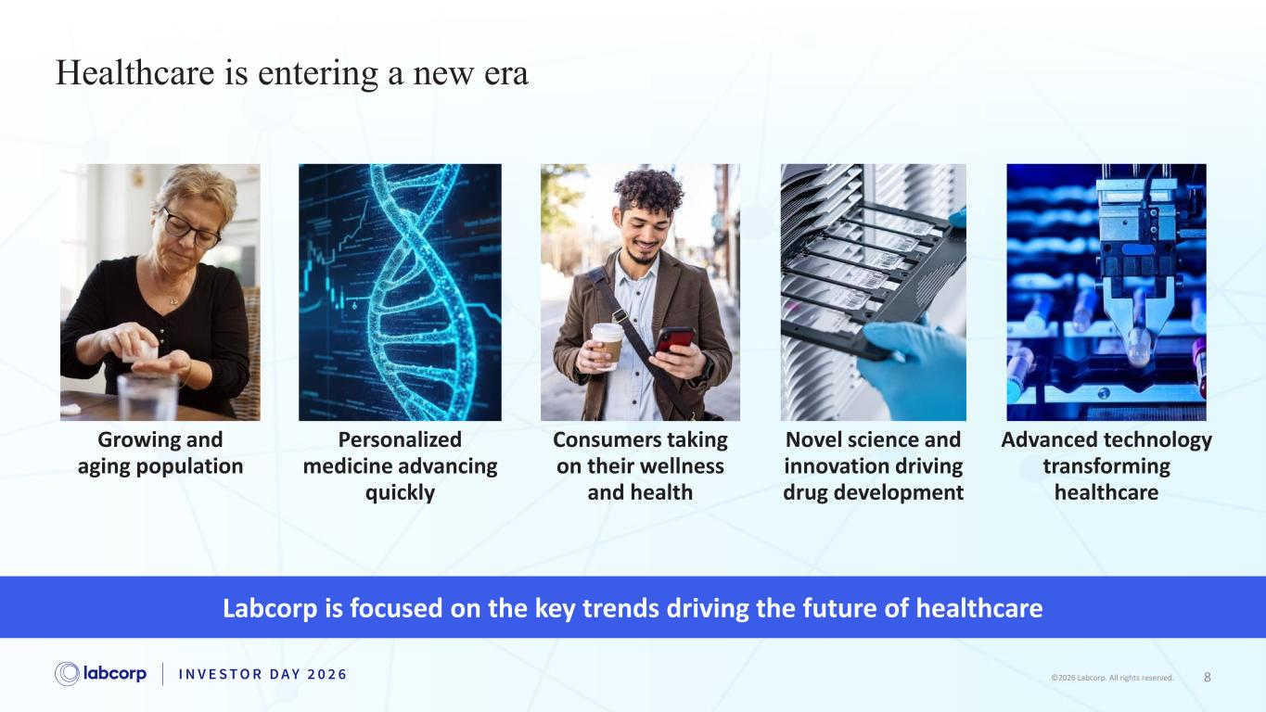
8©2026 Labcorp. All rights reserved.2026 Labcorp. All rights reserved. Healthcare is entering a new era Growing and aging population Personalized medicine advancing quickly Consumers taking on their wellness and health Advanced technology transforming healthcare Novel science and innovation driving drug development Labcorp is focused on the key trends driving the future of healthcare

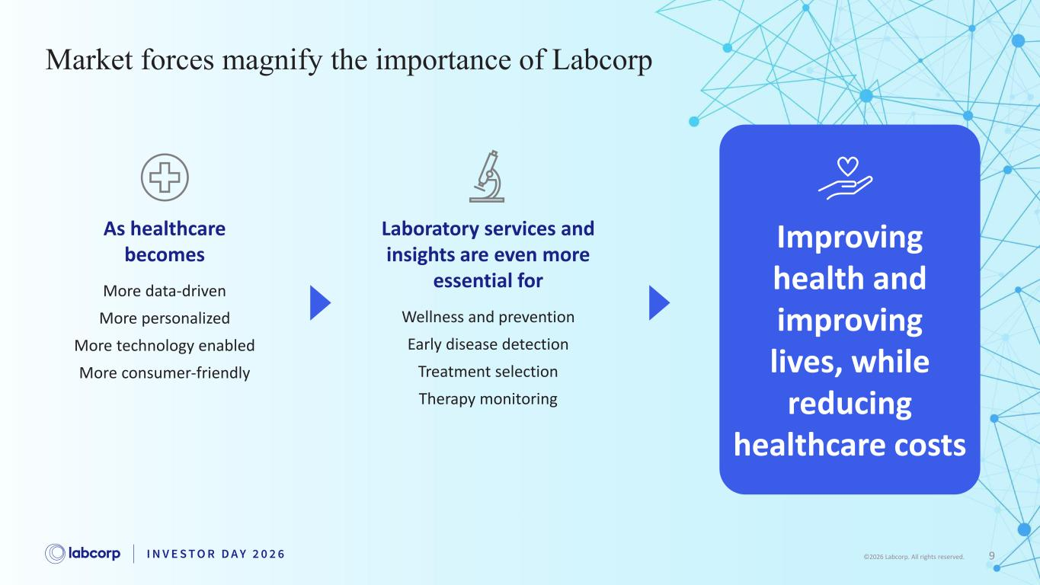
Market forces magnify the importance of Labcorp As healthcare becomes More data-driven More personalized More technology enabled More consumer-friendly Laboratory services and insights are even more essential for Wellness and prevention Early disease detection Treatment selection Therapy monitoring Improving health and improving lives, while reducing healthcare costs 9©2026 Labcorp. All rights reserved.

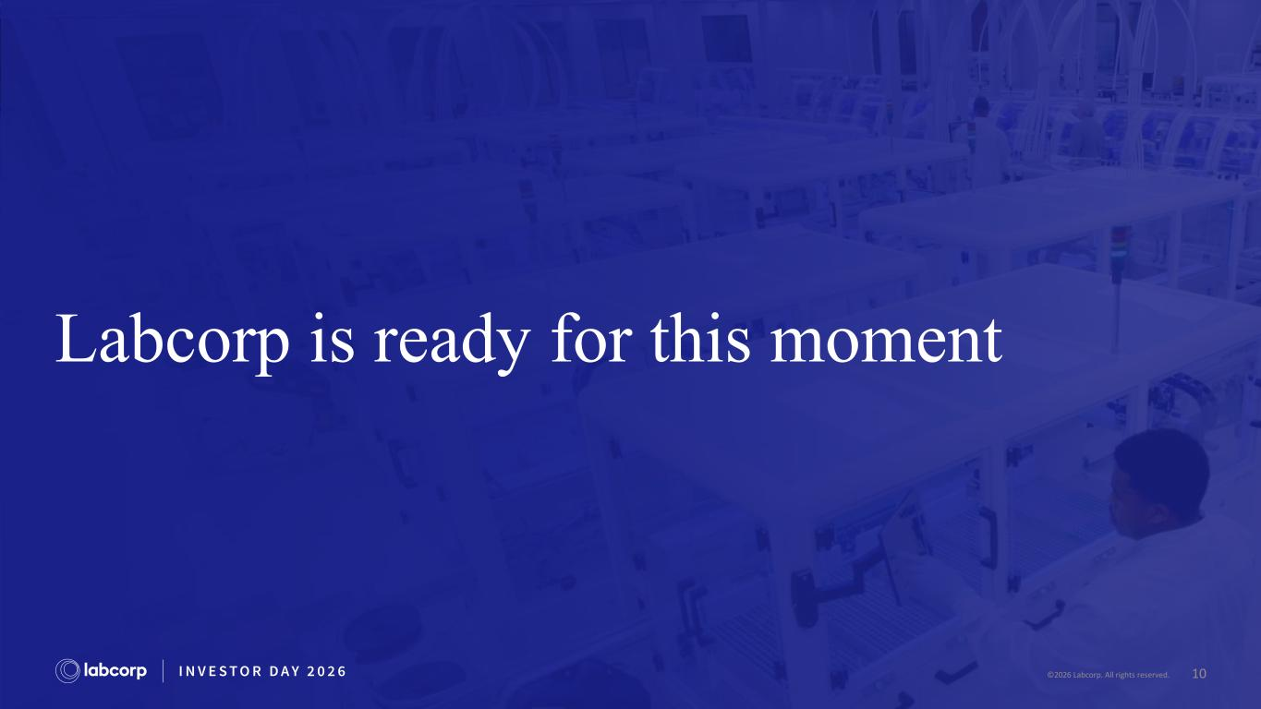
10©2026 Labcorp. All rights reserved. Labcorp is ready for this moment 2026 Labcorp. All rights reserved.

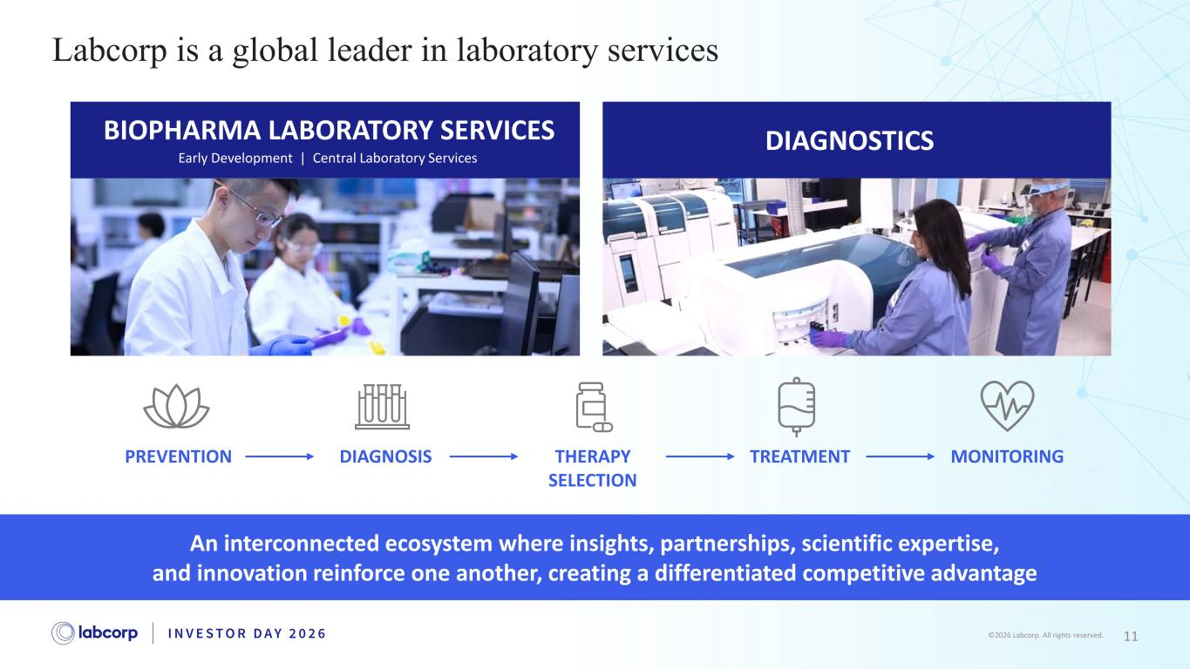
11©2026 Labcorp. All rights reserved. An interconnected ecosystem where insights, partnerships, scientific expertise, and innovation reinforce one another, creating a differentiated competitive advantage Labcorp is a global leader in laboratory services DIAGNOSTICSBIOPHARMA LABORATORY SERVICES Early Development | Central Laboratory Services PREVENTION DIAGNOSIS THERAPY SELECTION TREATMENT MONITORING

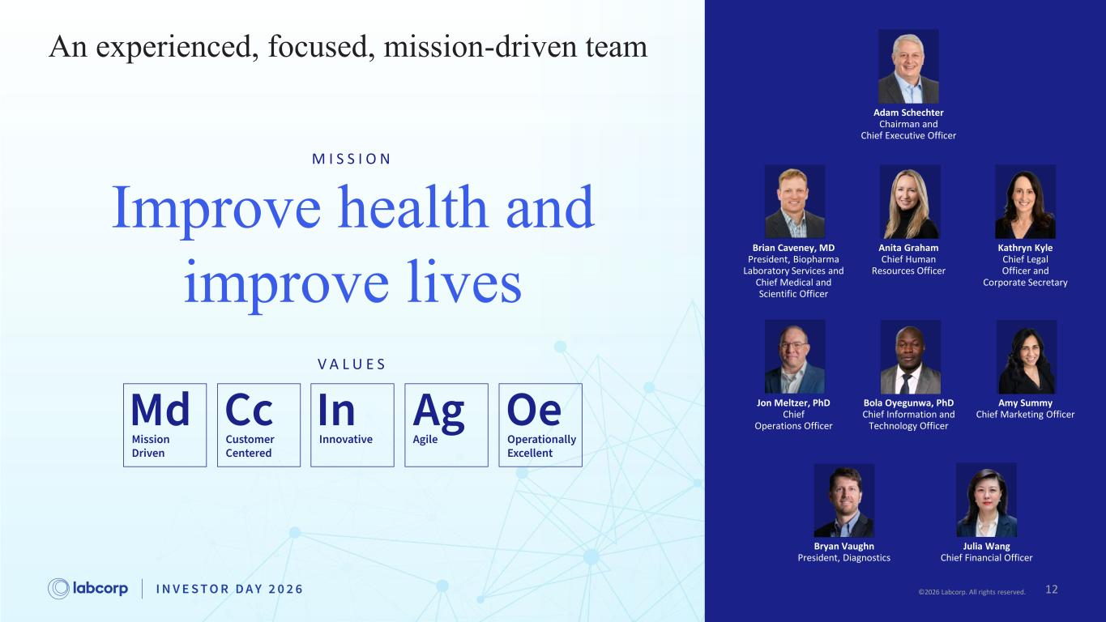
12©2026 Labcorp. All rights reserved. Amy Summy Chief Marketing Officer Adam Schechter Chairman and Chief Executive Officer Anita Graham Chief Human Resources Officer Brian Caveney, MD President, Biopharma Laboratory Services and Chief Medical and Scientific Officer Jon Meltzer, PhD Chief Operations Officer Bryan Vaughn President, Diagnostics Kathryn Kyle Chief Legal Officer and Corporate Secretary Julia Wang Chief Financial Officer Bola Oyegunwa, PhD Chief Information and Technology Officer V A L U E S Improve health and improve lives An experienced, focused, mission-driven team M I S S I O N 122026 Labcorp. All rights reserved.

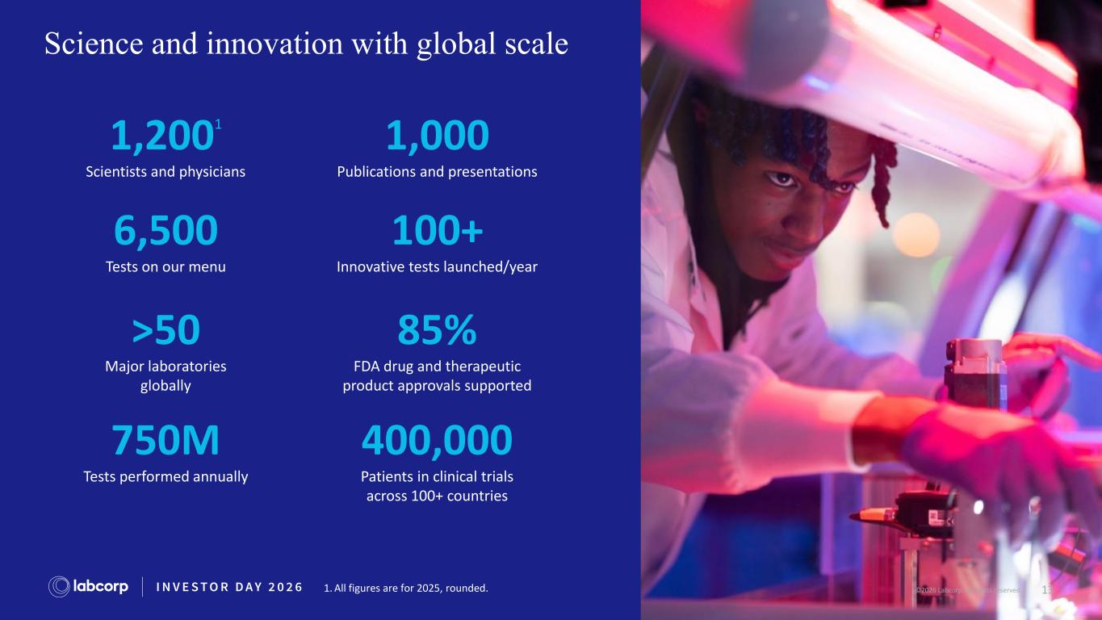
13©2026 Labcorp. All rights reserved. Science and innovation with global scale 1,2001 Scientists and physicians 1,000 Publications and presentations 6,500 Tests on our menu 100+ Innovative tests launched/year >50 Major laboratories globally 85% FDA drug and therapeutic product approvals supported 750M Tests performed annually 400,000 Patients in clinical trials across 100+ countries 2026 Labcorp. All rights reserved.1. All figures are for 2025, rounded.

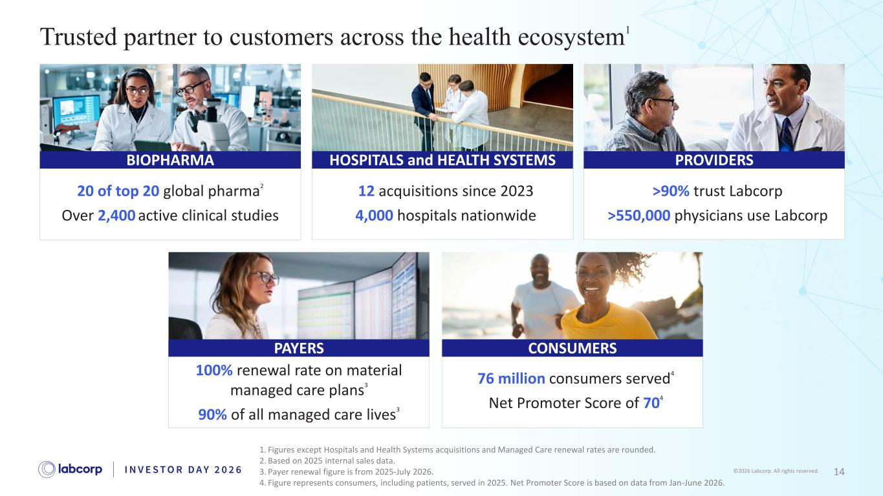
14©2026 Labcorp. All rights reserved. Trusted partner to customers across the health ecosystem1 1. Figures except Hospitals and Health Systems acquisitions and Managed Care renewal rates are rounded. 2. Based on 2025 internal sales data. 3. Payer renewal figure is from 2025-July 2026. 4. Figure represents consumers, including patients, served in 2025. Net Promoter Score is based on data from Jan-June 2026. PROVIDERS >90% trust Labcorp >550,000 physicians use Labcorp BIOPHARMA 20 of top 20 global pharma2 Over 2,400 active clinical studies 12 acquisitions since 2023 4,000 hospitals nationwide HOSPITALS and HEALTH SYSTEMS PAYERS 100% renewal rate on material managed care plans3 90% of all managed care lives3 76 million consumers served4 Net Promoter Score of 704 CONSUMERS

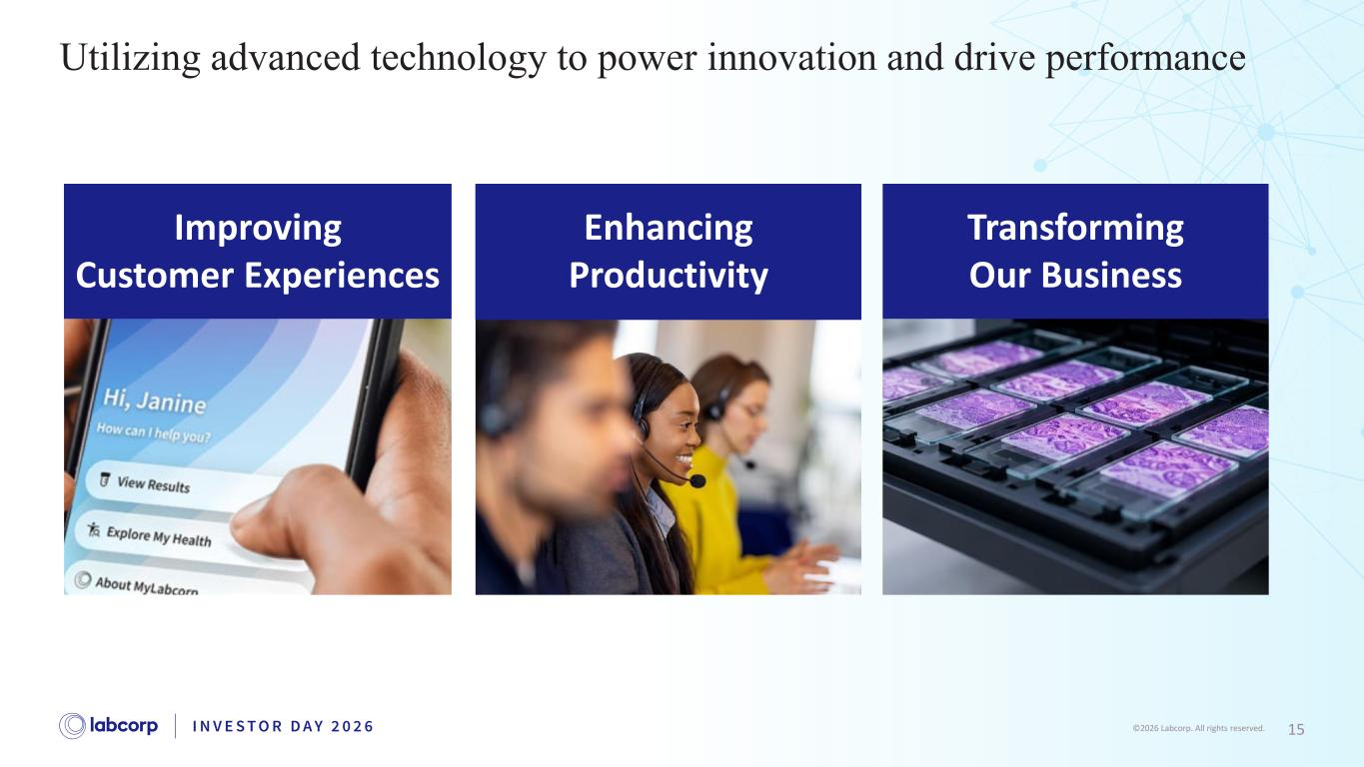
15©2026 Labcorp. All rights reserved. Utilizing advanced technology to power innovation and drive performance Improving Customer Experiences Enhancing Productivity Transforming Our Business


16©2026 Labcorp. All rights reserved. Strategic priorities focus on high-growth areas

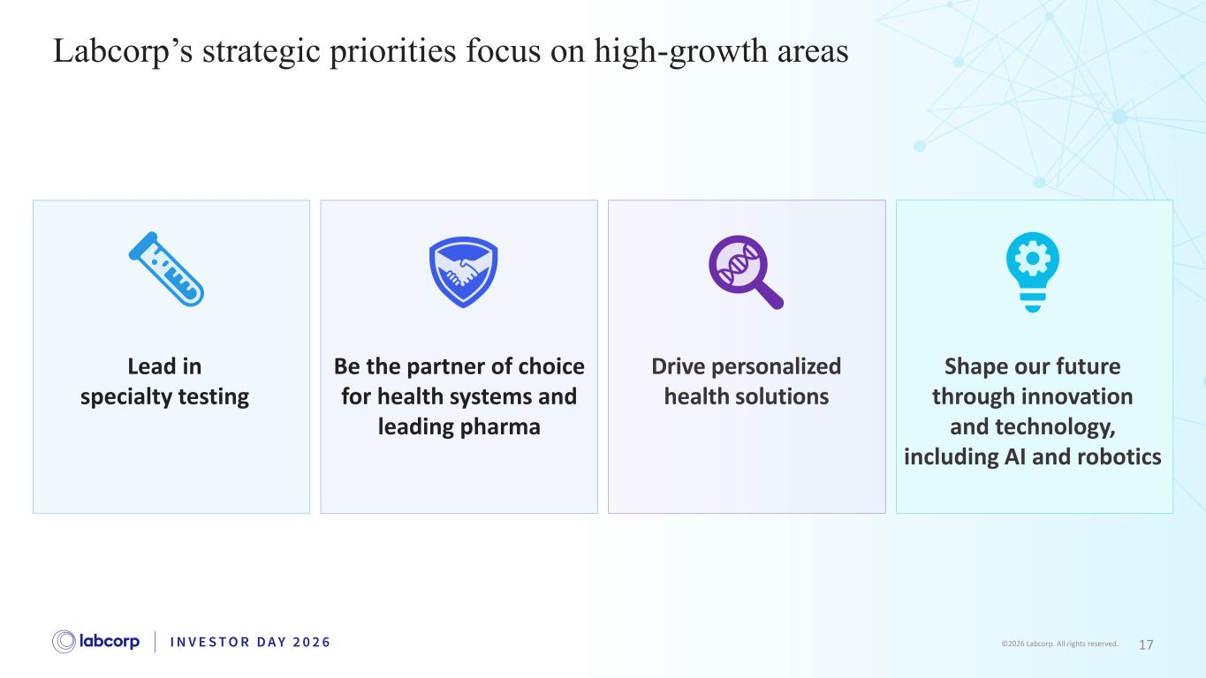
17©2026 Labcorp. All rights reserved. Lead in specialty testing Drive personalized health solutions Be the partner of choice for health systems and leading pharma Shape our future through innovation and technology, including AI and robotics Labcorp’s strategic priorities focus on high-growth areas

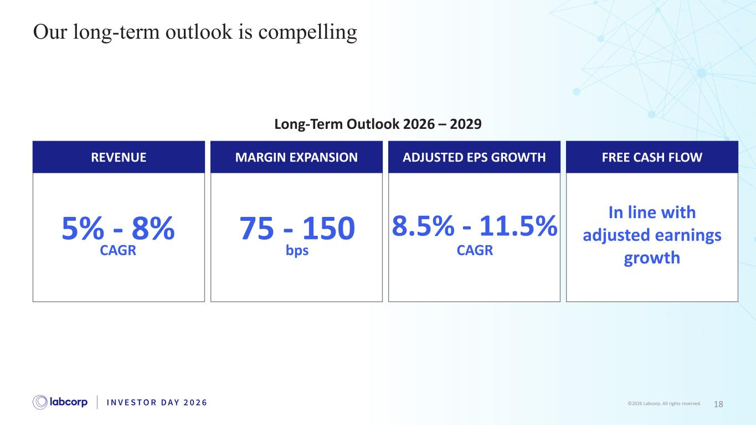
18©2026 Labcorp. All rights reserved. Our long-term outlook is compelling Long-Term Outlook 2026 – 2029 CAGR 5% - 8% REVENUE MARGIN EXPANSION ADJUSTED EPS GROWTH FREE CASH FLOW bps 75 - 150 CAGR 8.5% - 11.5% In line with adjusted earnings growth

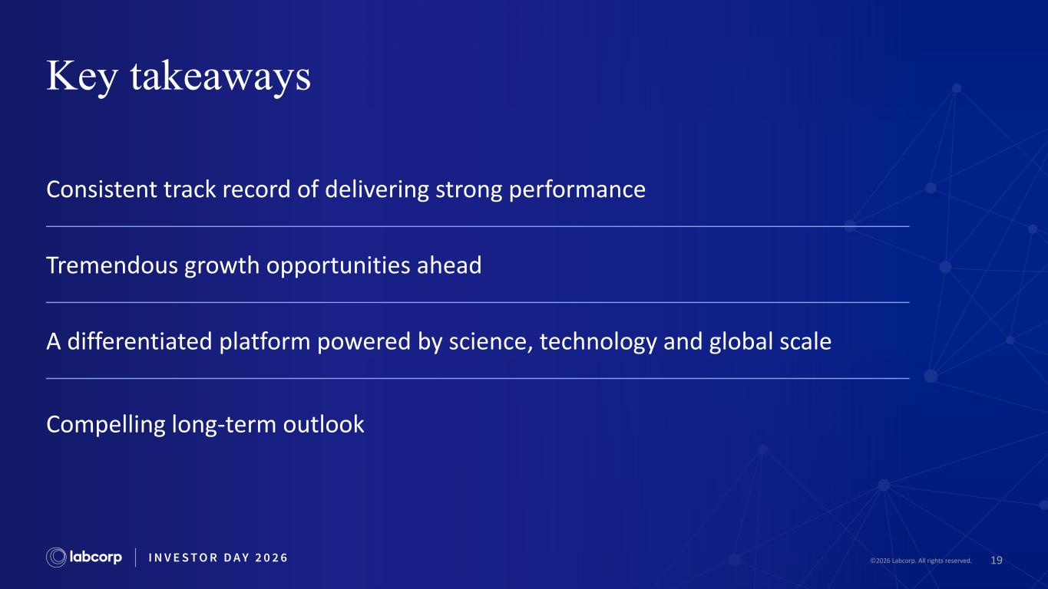
19©2026 Labcorp. All rights reserved. Key takeaways Consistent track record of delivering strong performance Tremendous growth opportunities ahead A differentiated platform powered by science, technology and global scale Compelling long-term outlook

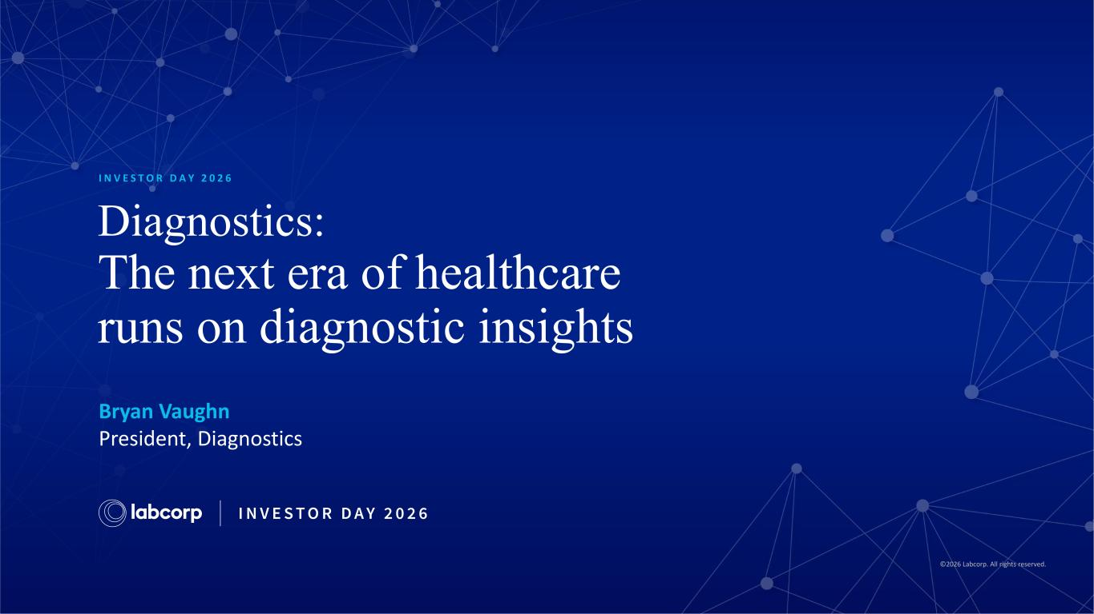
©2026 Labcorp. All rights reserved. Diagnostics: The next era of healthcare runs on diagnostic insights Bryan Vaughn President, Diagnostics I N V E S T O R D A Y 2 0 2 6

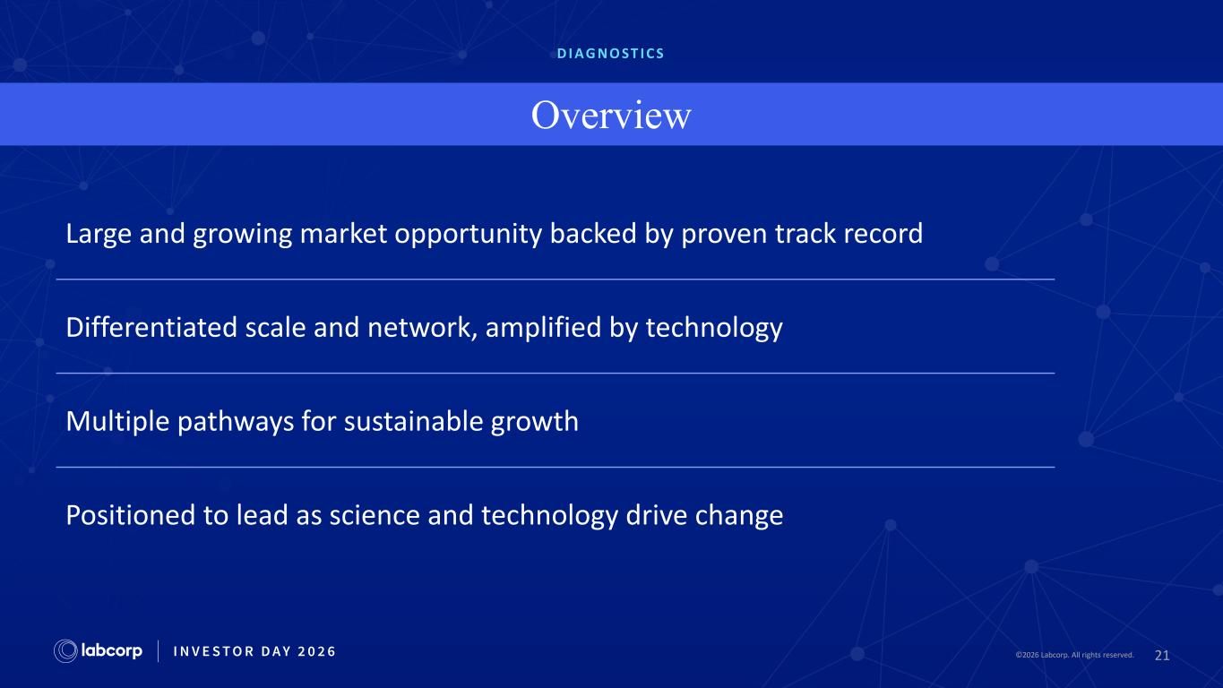
21©2026 Labcorp. All rights reserved.2026 Labcorp. All rights reserved. D I A G N O ST I C S Overview Large and growing market opportunity backed by proven track record Differentiated scale and network, amplified by technology Multiple pathways for sustainable growth Positioned to lead as science and technology drive change

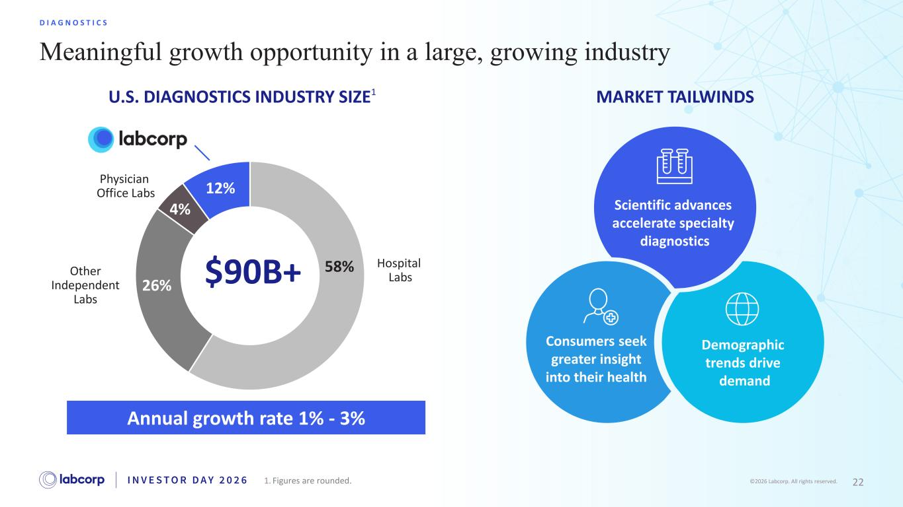
22©2026 Labcorp. All rights reserved. Meaningful growth opportunity in a large, growing industry D I A G N O S T I C S $90B+ 58% 26% 4% 12% Hospital LabsOther Independent Labs Physician Office Labs Annual growth rate 1% - 3% MARKET TAILWINDS U.S. DIAGNOSTICS INDUSTRY SIZE1 Demographic trends drive demand Consumers seek greater insight into their health Scientific advances accelerate specialty diagnostics 1. Figures are rounded.

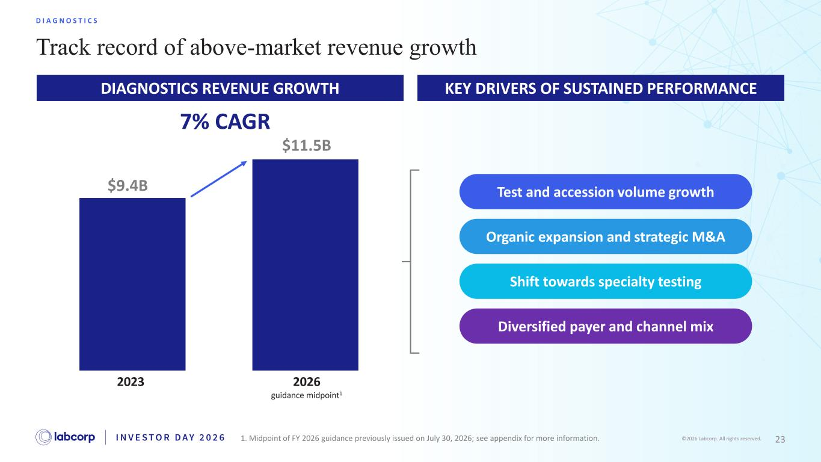
23©2026 Labcorp. All rights reserved. KEY DRIVERS OF SUSTAINED PERFORMANCE Track record of above-market revenue growth D I A G N O S T I C S Test and accession volume growth Organic expansion and strategic M&A Shift towards specialty testing Diversified payer and channel mix DIAGNOSTICS REVENUE GROWTH 2023 2026 guidance midpoint1 1. Midpoint of FY 2026 guidance previously issued on July 30, 2026; see appendix for more information. $9.4B $11.5B 7% CAGR

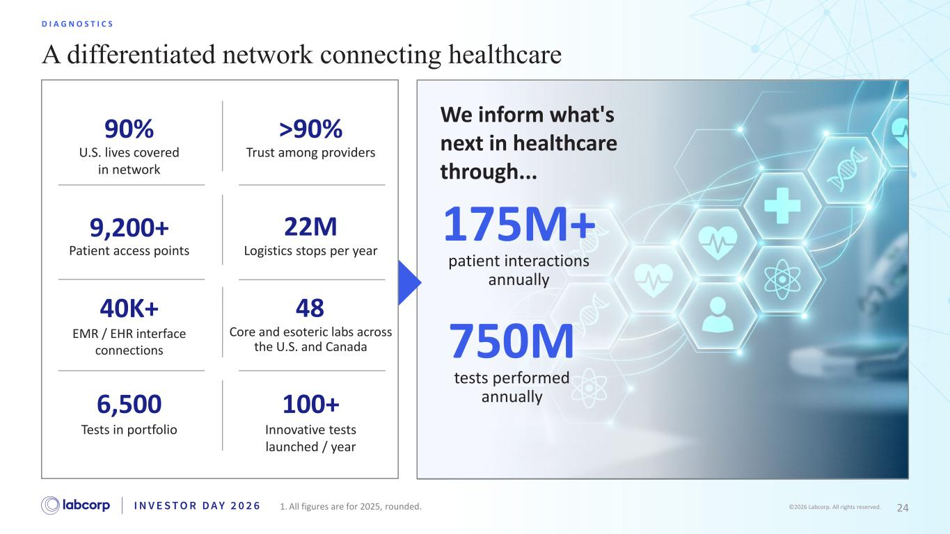
24©2026 Labcorp. All rights reserved. A differentiated network connecting healthcare D I A G N O S T I C S We inform what's next in healthcare through... 175M+ patient interactions annually 750M tests performed annually 22M Logistics stops per year 100+ Innovative tests launched / year 90% U.S. lives covered in network >90% Trust among providers 48 Core and esoteric labs across the U.S. and Canada 6,500 Tests in portfolio 9,200+ Patient access points 40K+ EMR / EHR interface connections 1. All figures are for 2025, rounded.

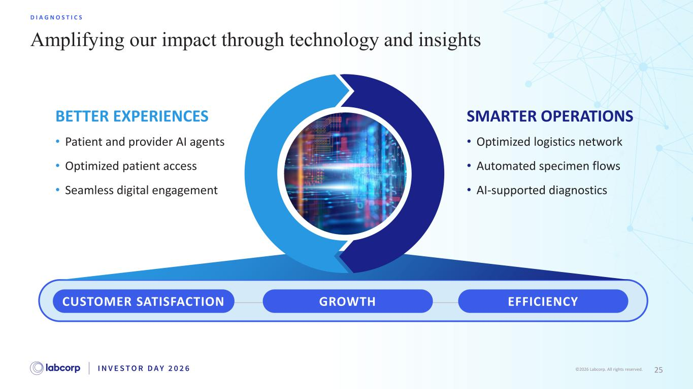
25©2026 Labcorp. All rights reserved. Amplifying our impact through technology and insights D I A G N O S T I C S BETTER EXPERIENCES SMARTER OPERATIONS • Patient and provider AI agents • Optimized patient access • Seamless digital engagement • Optimized logistics network • Automated specimen flows • AI-supported diagnostics GROWTHCUSTOMER SATISFACTION EFFICIENCY


26©2026 Labcorp. All rights reserved. Driving growth through specialty, partnerships and M&A, and consumer-centric solutions

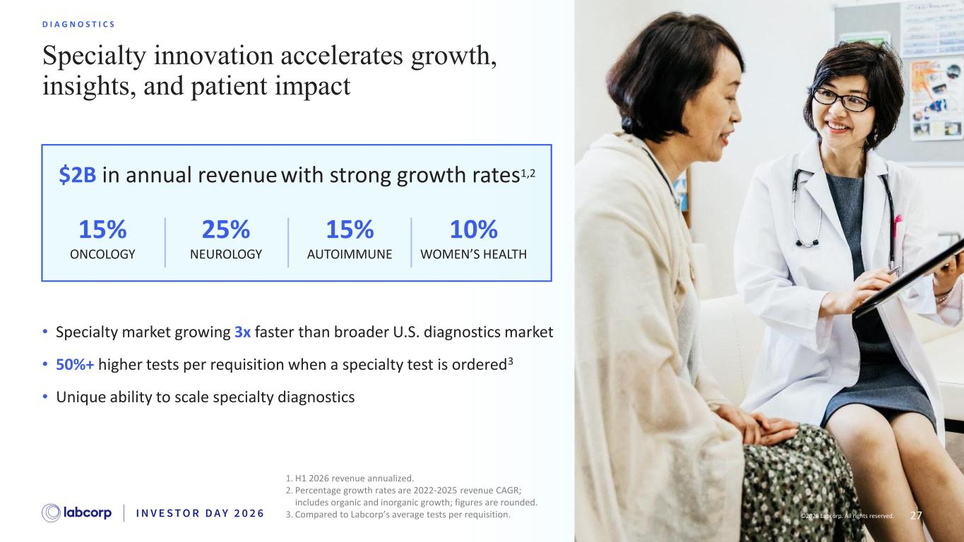
27©2026 Labcorp. All rights reserved. Specialty innovation accelerates growth, insights, and patient impact D I A G N O S T I C S 1. H1 2026 revenue annualized. 2. Percentage growth rates are 2022-2025 revenue CAGR; includes organic and inorganic growth; figures are rounded. 3. Compared to Labcorp’s average tests per requisition. • Specialty market growing 3x faster than broader U.S. diagnostics market • 50%+ higher tests per requisition when a specialty test is ordered3 • Unique ability to scale specialty diagnostics 2026 Labcorp. All rights reserved. 15% ONCOLOGY 15% AUTOIMMUNE 10% WOMEN’S HEALTH 25% NEUROLOGY $2B in annual revenue with strong growth rates1,2

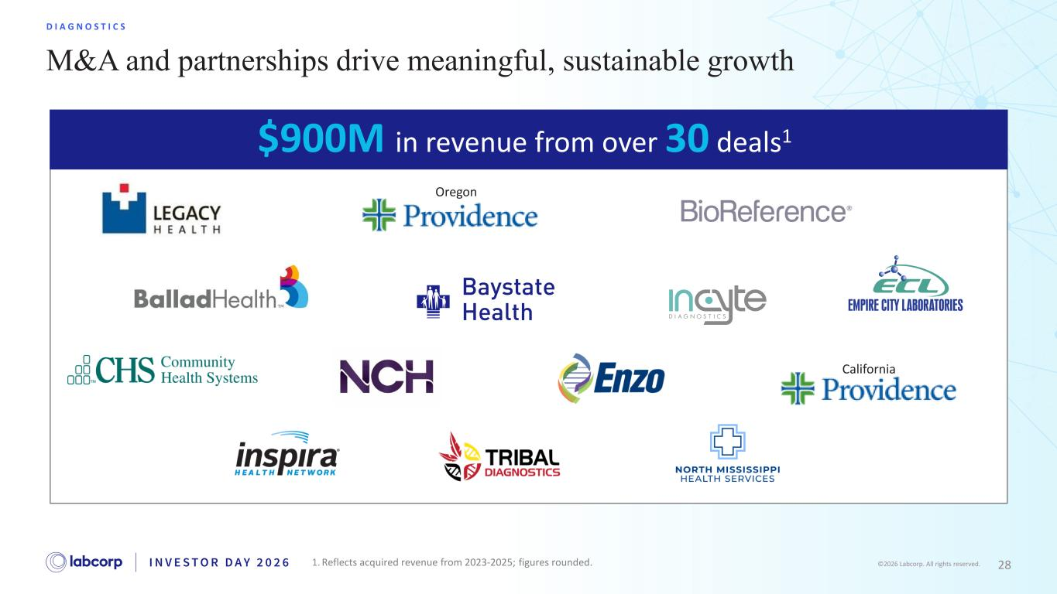
28©2026 Labcorp. All rights reserved. M&A and partnerships drive meaningful, sustainable growth D I A G N O S T I C S California Oregon $900M in revenue from over 30 deals1 1. Reflects acquired revenue from 2023-2025; figures rounded.

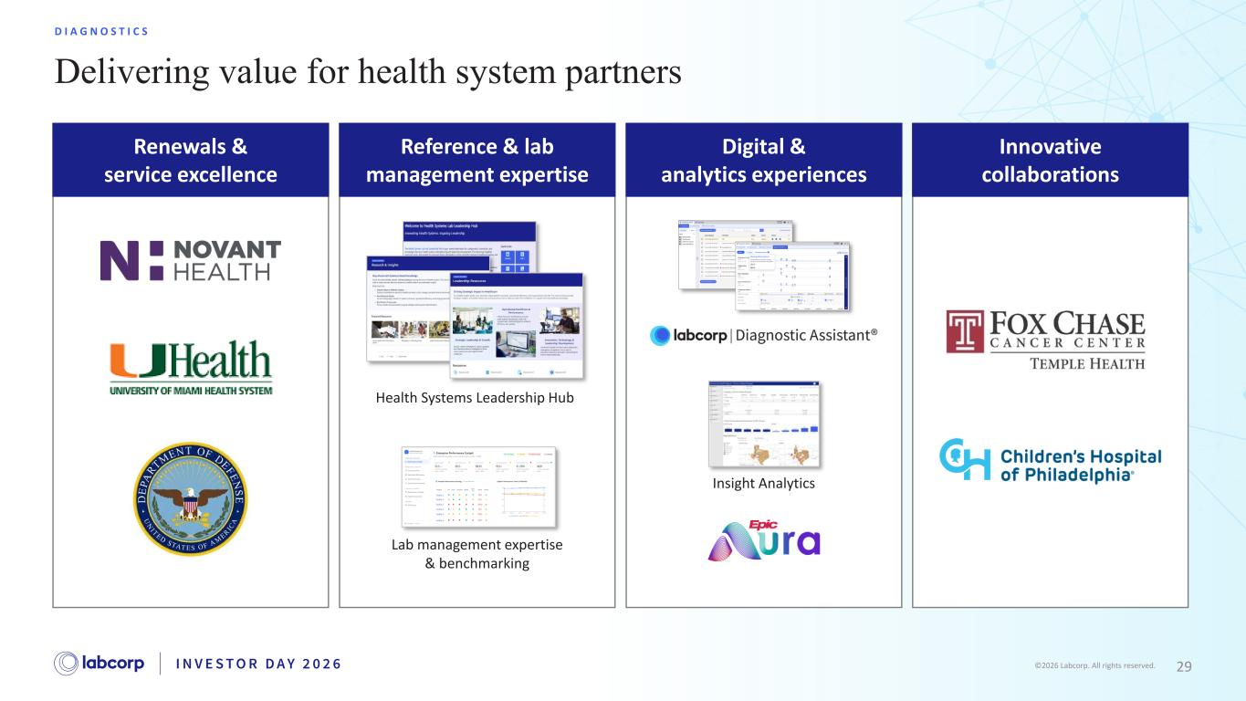
29©2026 Labcorp. All rights reserved. Renewals & service excellence Reference & lab management expertise Digital & analytics experiences Innovative collaborations Delivering value for health system partners D I A G N O S T I C S Insight Analytics Health Systems Leadership Hub Lab management expertise & benchmarking

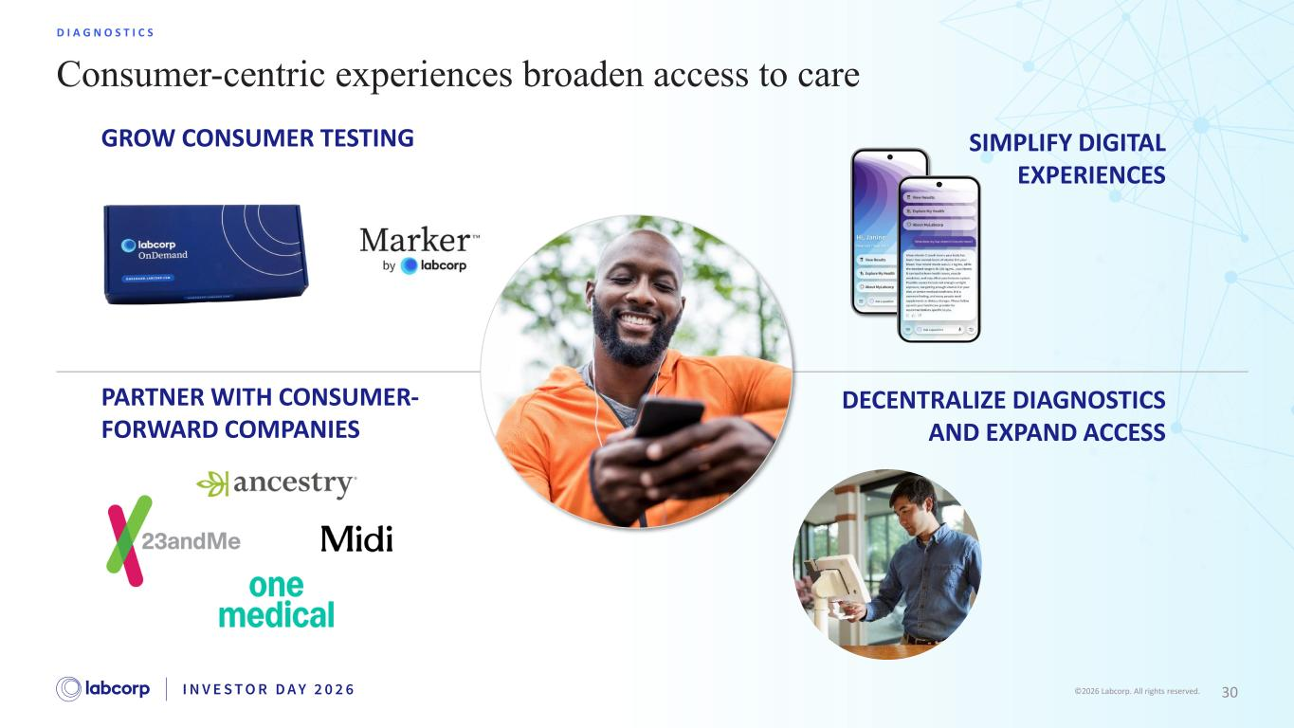
30©2026 Labcorp. All rights reserved. Consumer-centric experiences broaden access to care D I A G N O S T I C S DECENTRALIZE DIAGNOSTICS AND EXPAND ACCESS SIMPLIFY DIGITAL EXPERIENCES PARTNER WITH CONSUMER- FORWARD COMPANIES GROW CONSUMER TESTING

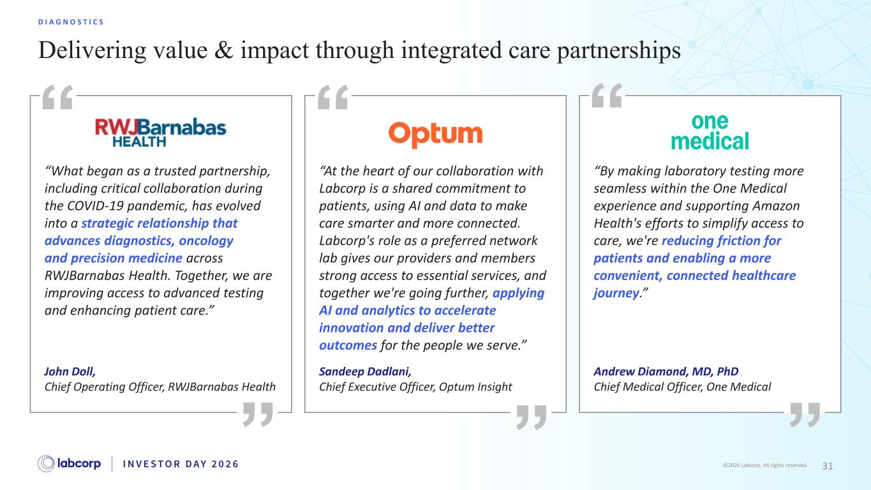
31©2026 Labcorp. All rights reserved. Delivering value & impact through integrated care partnerships D I A G N O S T I C S “What began as a trusted partnership, including critical collaboration during the COVID-19 pandemic, has evolved into a strategic relationship that advances diagnostics, oncology and precision medicine across RWJBarnabas Health. Together, we are improving access to advanced testing and enhancing patient care.” John Doll, Chief Operating Officer, RWJBarnabas Health “At the heart of our collaboration with Labcorp is a shared commitment to patients, using AI and data to make care smarter and more connected. Labcorp's role as a preferred network lab gives our providers and members strong access to essential services, and together we're going further, applying AI and analytics to accelerate innovation and deliver better outcomes for the people we serve.” Sandeep Dadlani, Chief Executive Officer, Optum Insight “By making laboratory testing more seamless within the One Medical experience and supporting Amazon Health's efforts to simplify access to care, we're reducing friction for patients and enabling a more convenient, connected healthcare journey.” Andrew Diamond, MD, PhD Chief Medical Officer, One Medical

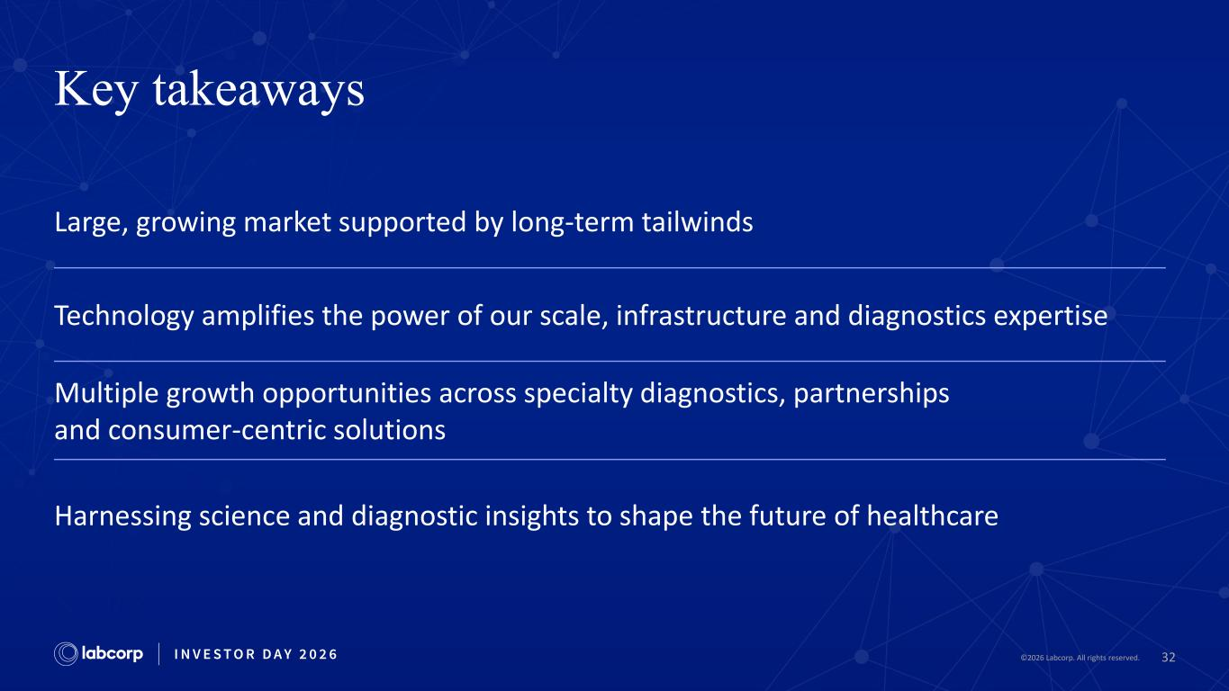
32©2026 Labcorp. All rights reserved. Key takeaways Large, growing market supported by long-term tailwinds Technology amplifies the power of our scale, infrastructure and diagnostics expertise Multiple growth opportunities across specialty diagnostics, partnerships and consumer-centric solutions Harnessing science and diagnostic insights to shape the future of healthcare

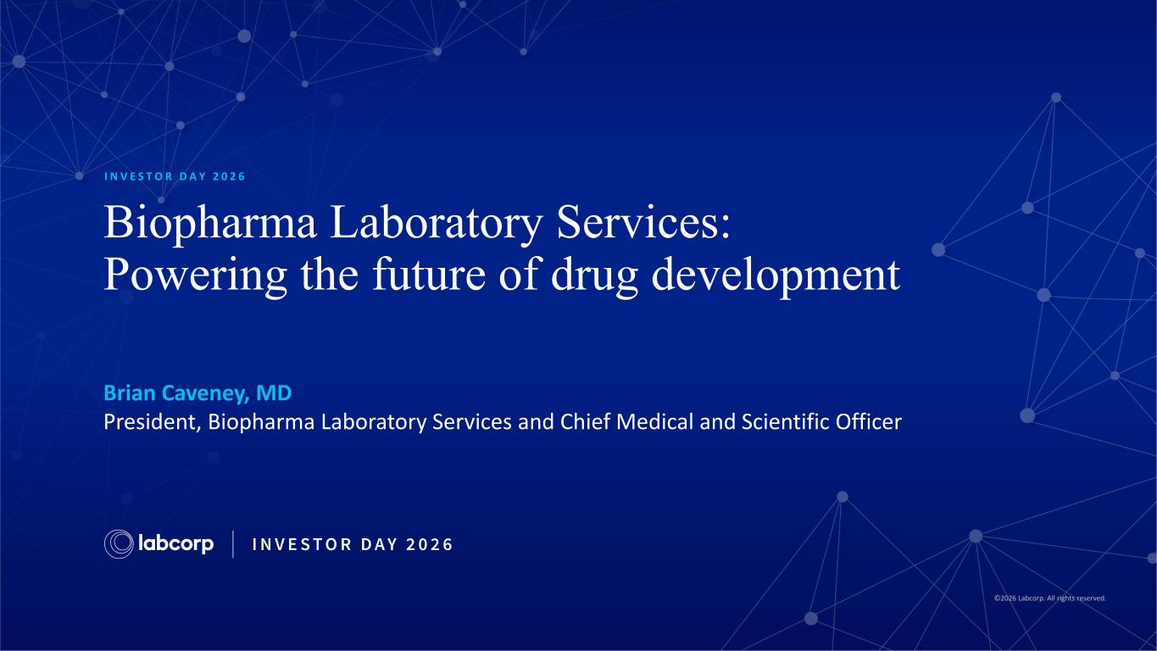
©2026 Labcorp. All rights reserved. Biopharma Laboratory Services: Powering the future of drug development I N V E S T O R D A Y 2 0 2 6 Brian Caveney, MD President, Biopharma Laboratory Services and Chief Medical and Scientific Officer

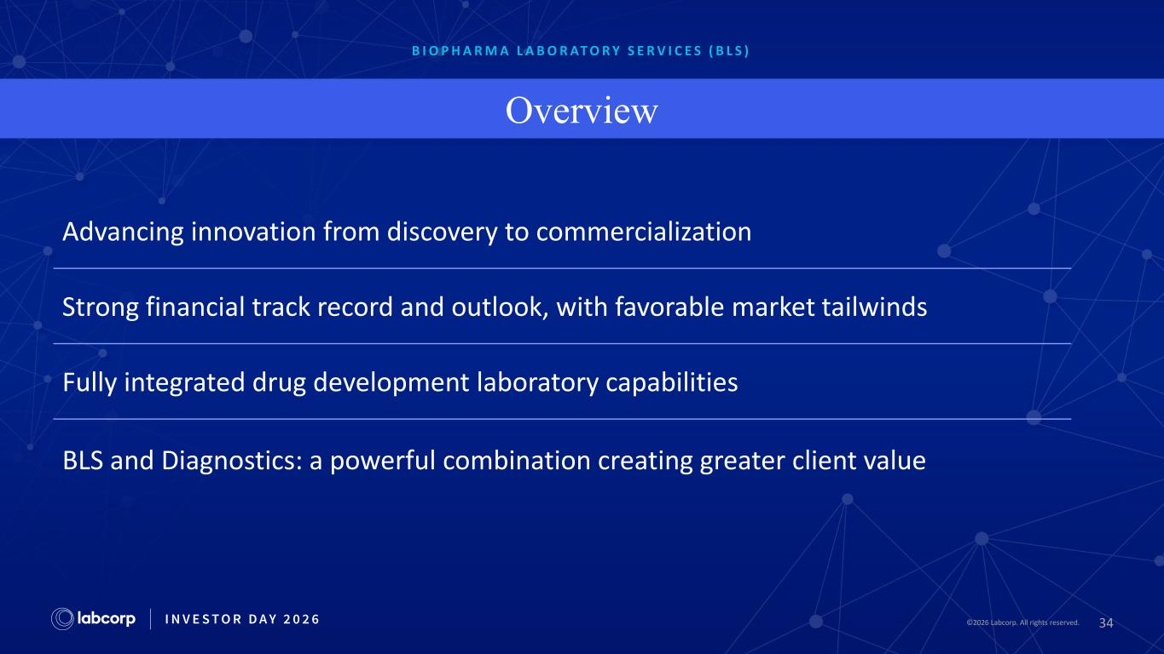
34©2026 Labcorp. All rights reserved.2026 Labcorp. All rights reserved. B I O P H A R M A L A B O R AT O R Y S E R V I C E S ( B L S ) Overview Advancing innovation from discovery to commercialization Strong financial track record and outlook, with favorable market tailwinds Fully integrated drug development laboratory capabilities BLS and Diagnostics: a powerful combination creating greater client value

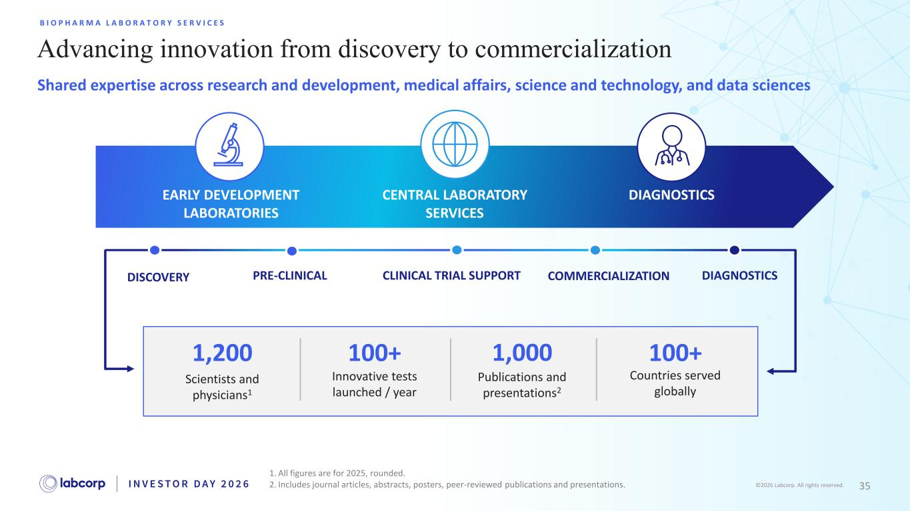
35©2026 Labcorp. All rights reserved. Advancing innovation from discovery to commercialization B I O P H A R M A L A B O R A T O R Y S E R V I C E S 1. All figures are for 2025, rounded. 2. Includes journal articles, abstracts, posters, peer-reviewed publications and presentations. Shared expertise across research and development, medical affairs, science and technology, and data sciences DISCOVERY PRE-CLINICAL CLINICAL TRIAL SUPPORT COMMERCIALIZATION DIAGNOSTICS EARLY DEVELOPMENT LABORATORIES CENTRAL LABORATORY SERVICES DIAGNOSTICS 1,200 Scientists and physicians1 100+ Innovative tests launched / year Publications and presentations2 1,000 100+ Countries served globally

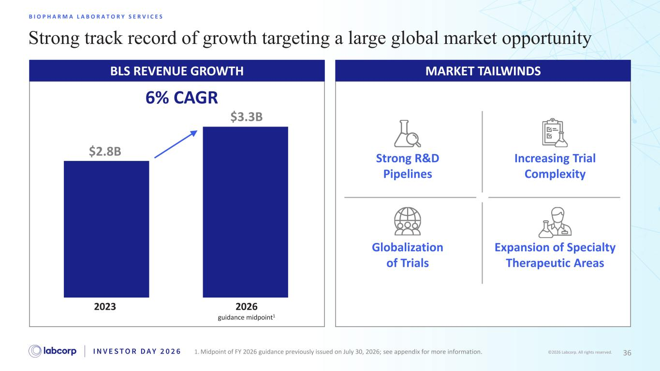
36©2026 Labcorp. All rights reserved. BLS REVENUE GROWTH Strong track record of growth targeting a large global market opportunity B I O P H A R M A L A B O R A T O R Y S E R V I C E S MARKET TAILWINDS Strong R&D Pipelines Increasing Trial Complexity Globalization of Trials Expansion of Specialty Therapeutic Areas 2023 2026 guidance midpoint1 1. Midpoint of FY 2026 guidance previously issued on July 30, 2026; see appendix for more information. $2.8B $3.3B 6% CAGR

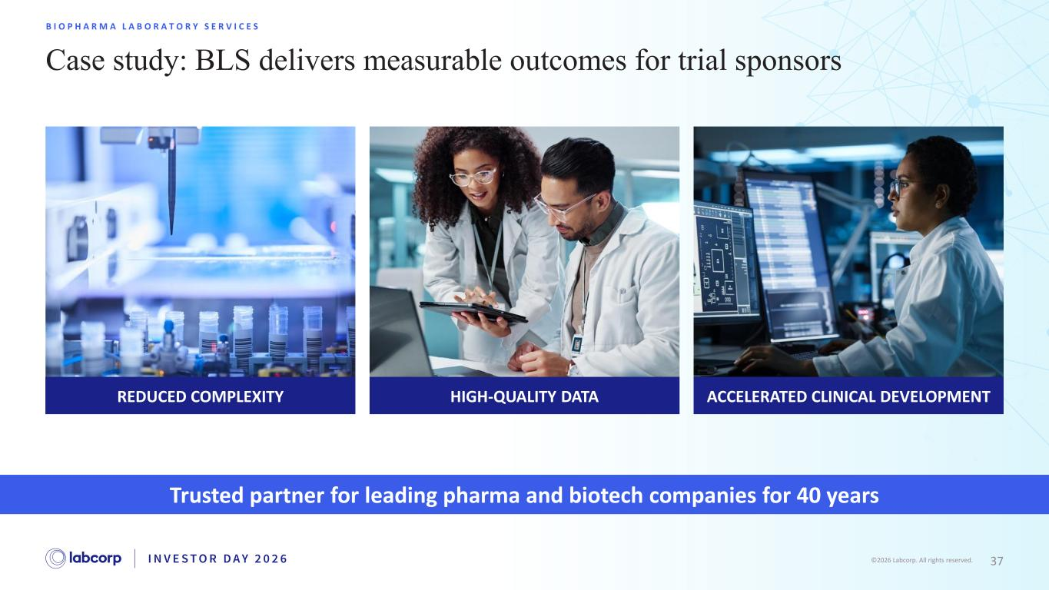
37©2026 Labcorp. All rights reserved. Case study: BLS delivers measurable outcomes for trial sponsors B I O P H A R M A L A B O R A T O R Y S E R V I C E S Trusted partner for leading pharma and biotech companies for 40 years ACCELERATED CLINICAL DEVELOPMENTREDUCED COMPLEXITY HIGH-QUALITY DATA

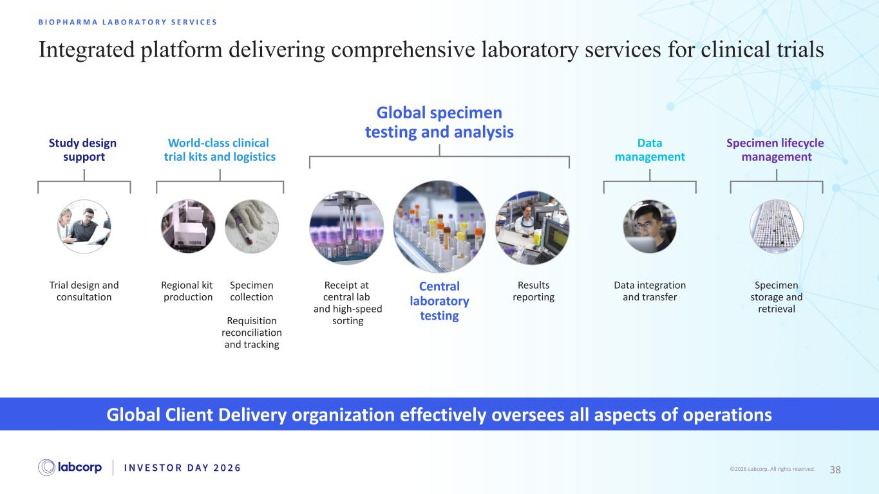
38©2026 Labcorp. All rights reserved. Integrated platform delivering comprehensive laboratory services for clinical trials B I O P H A R M A L A B O R A T O R Y S E R V I C E S Global Client Delivery organization effectively oversees all aspects of operations Results reporting Receipt at central lab and high-speed sorting Central laboratory testing Global specimen testing and analysis Trial design and consultation Study design support World-class clinical trial kits and logistics Regional kit production Specimen collection Requisition reconciliation and tracking Data integration and transfer Data management Specimen storage and retrieval Specimen lifecycle management

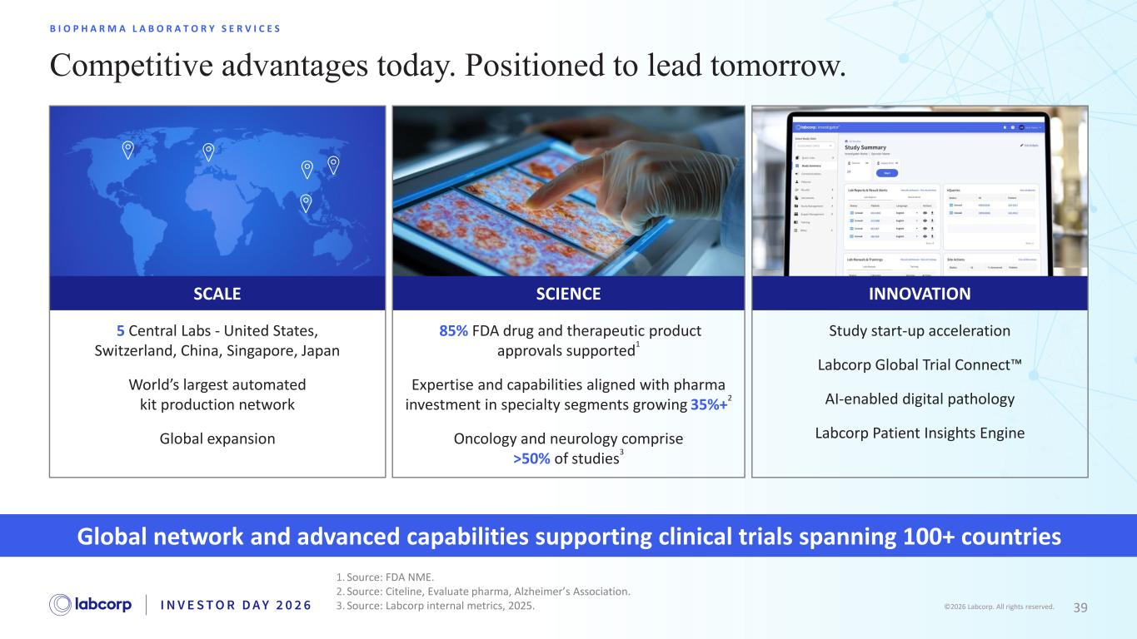
39©2026 Labcorp. All rights reserved. Competitive advantages today. Positioned to lead tomorrow. B I O P H A R M A L A B O R A T O R Y S E R V I C E S 1. Source: FDA NME. 2. Source: Citeline, Evaluate pharma, Alzheimer’s Association. 3. Source: Labcorp internal metrics, 2025. 5 Central Labs - United States, Switzerland, China, Singapore, Japan World’s largest automated kit production network Global expansion SCALE Global network and advanced capabilities supporting clinical trials spanning 100+ countries SCIENCE 85% FDA drug and therapeutic product approvals supported 1 Expertise and capabilities aligned with pharma investment in specialty segments growing 35%+ 2 Oncology and neurology comprise >50% of studies 3 Study start-up acceleration Labcorp Global Trial Connect AI-enabled digital pathology Labcorp Patient Insights Engine INNOVATION

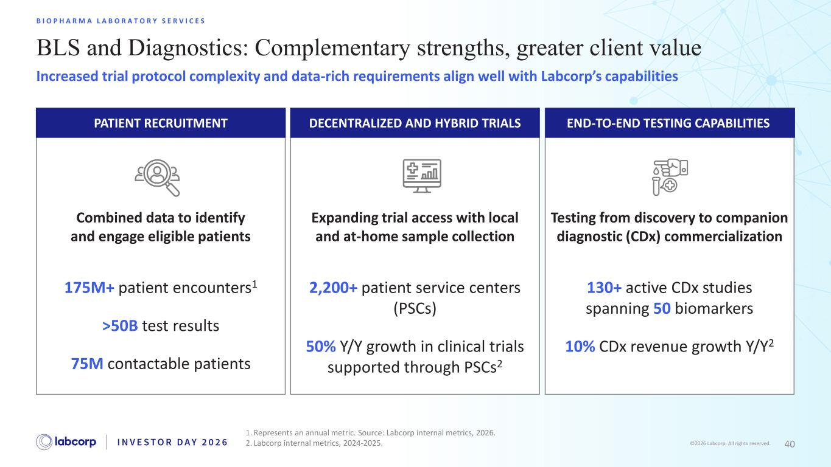
40©2026 Labcorp. All rights reserved. BLS and Diagnostics: Complementary strengths, greater client value B I O P H A R M A L A B O R A T O R Y S E R V I C E S Increased trial protocol complexity and data-rich requirements align well with Labcorp’s capabilities 1. Represents an annual metric. Source: Labcorp internal metrics, 2026. 2. Labcorp internal metrics, 2024-2025. PATIENT RECRUITMENT DECENTRALIZED AND HYBRID TRIALS END-TO-END TESTING CAPABILITIES Combined data to identify and engage eligible patients Expanding trial access with local and at-home sample collection Testing from discovery to companion diagnostic (CDx) commercialization 130+ active CDx studies spanning 50 biomarkers 10% CDx revenue growth Y/Y2 2,200+ patient service centers (PSCs) 50% Y/Y growth in clinical trials supported through PSCs2 175M+ patient encounters1 >50B test results 75M contactable patients

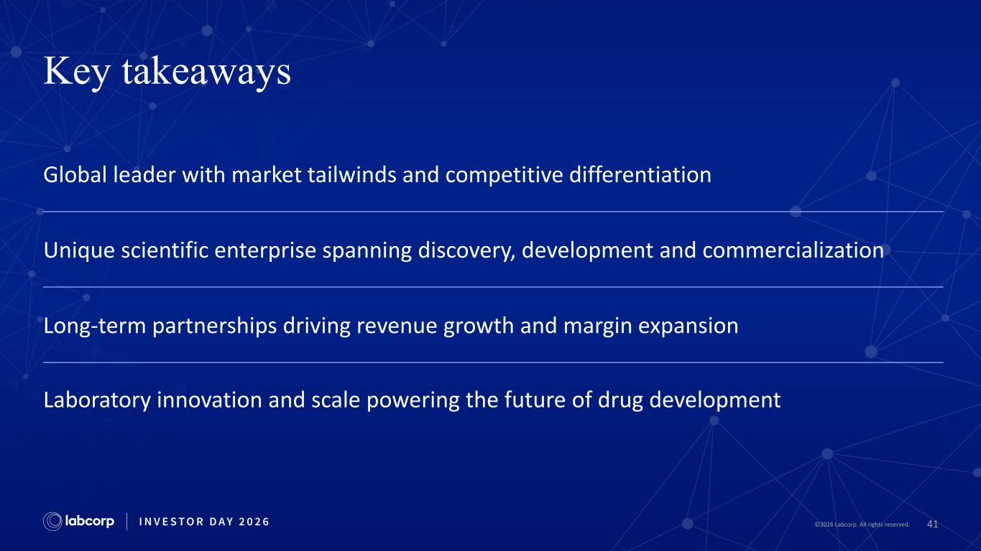
41©2026 Labcorp. All rights reserved. Key takeaways Global leader with market tailwinds and competitive differentiation Unique scientific enterprise spanning discovery, development and commercialization Long-term partnerships driving revenue growth and margin expansion Laboratory innovation and scale powering the future of drug development


42©2026 Labcorp. All rights reserved. Break

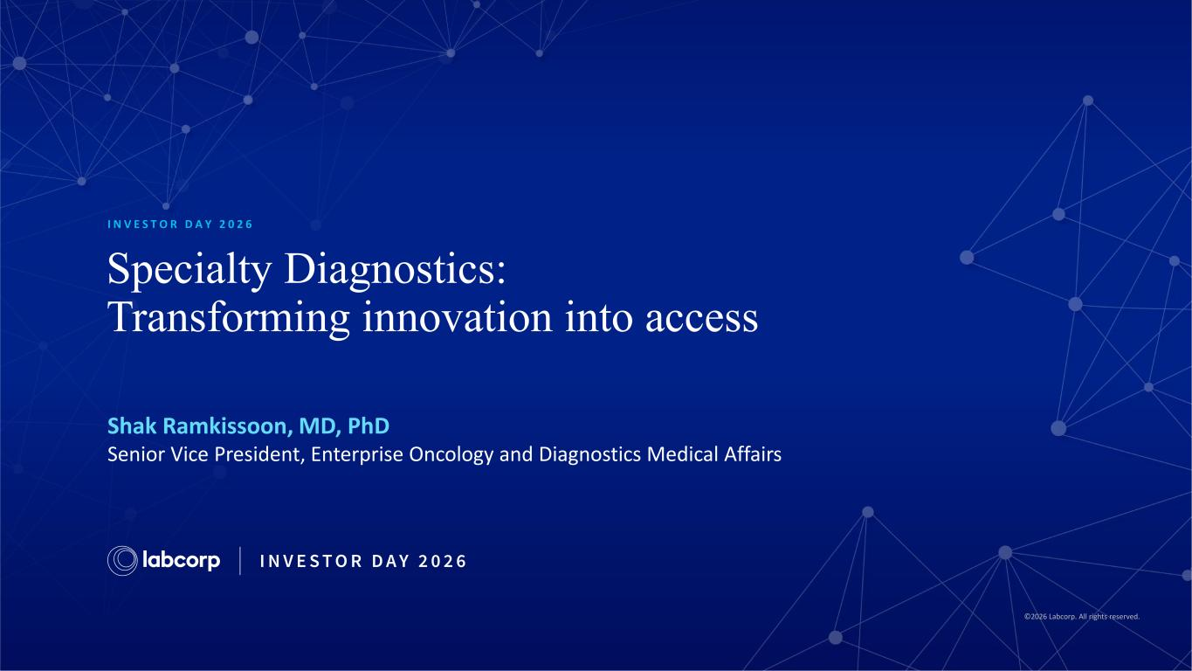
©2026 Labcorp. All rights reserved. Specialty Diagnostics: Transforming innovation into access I N V E S T O R D A Y 2 0 2 6 Shak Ramkissoon, MD, PhD Senior Vice President, Enterprise Oncology and Diagnostics Medical Affairs

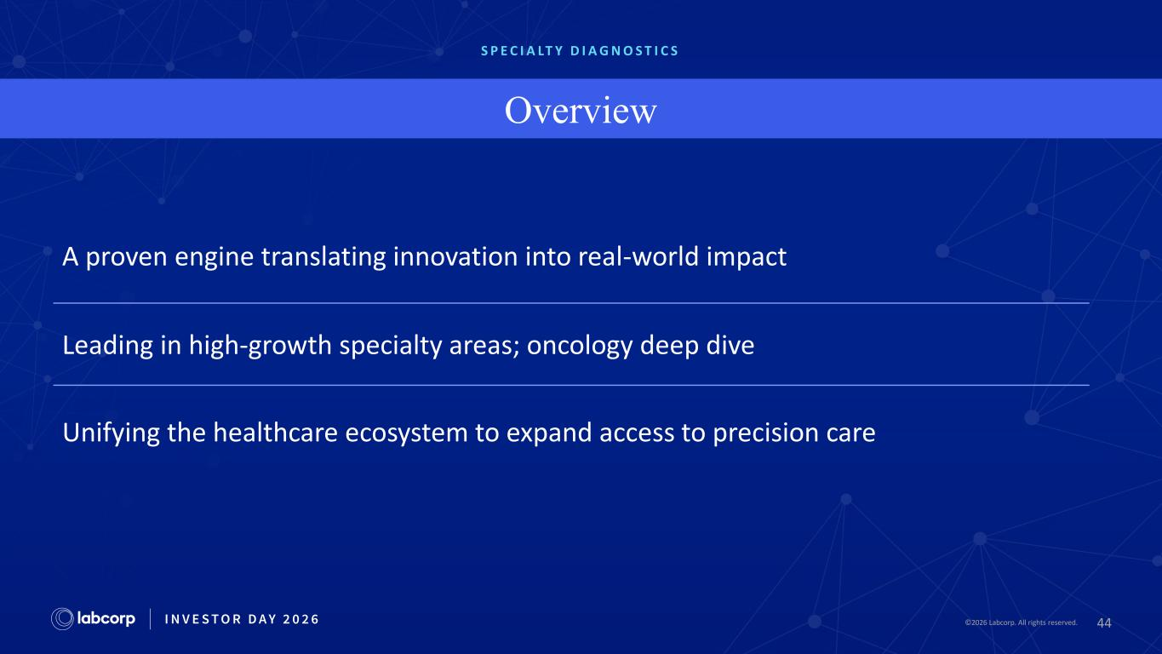
44©2026 Labcorp. All rights reserved.2026 Labcorp. All rights reserved. S P E C I A LT Y D I A G N O S T I C S Overview A proven engine translating innovation into real-world impact Leading in high-growth specialty areas; oncology deep dive Unifying the healthcare ecosystem to expand access to precision care

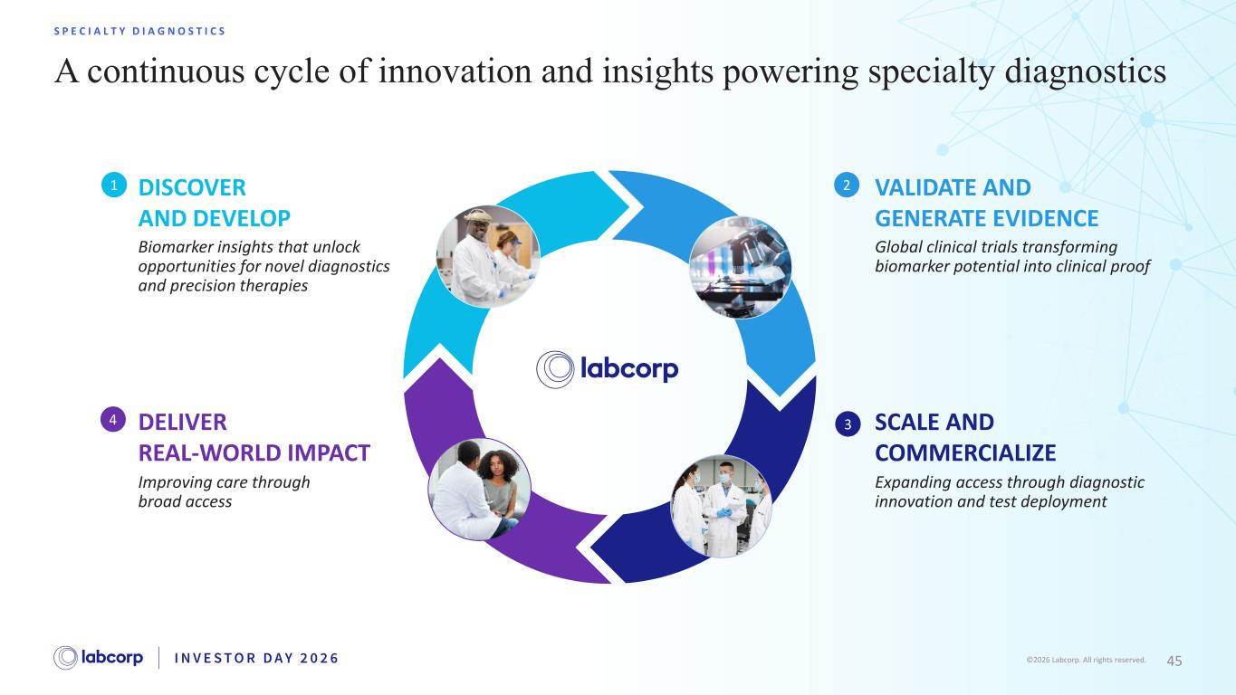
45©2026 Labcorp. All rights reserved. A continuous cycle of innovation and insights powering specialty diagnostics S P E C I A L T Y D I A G N O S T I C S DISCOVER AND DEVELOP Biomarker insights that unlock opportunities for novel diagnostics and precision therapies 1 DELIVER REAL-WORLD IMPACT Improving care through broad access 4 VALIDATE AND GENERATE EVIDENCE Global clinical trials transforming biomarker potential into clinical proof 2 SCALE AND COMMERCIALIZE Expanding access through diagnostic innovation and test deployment 3

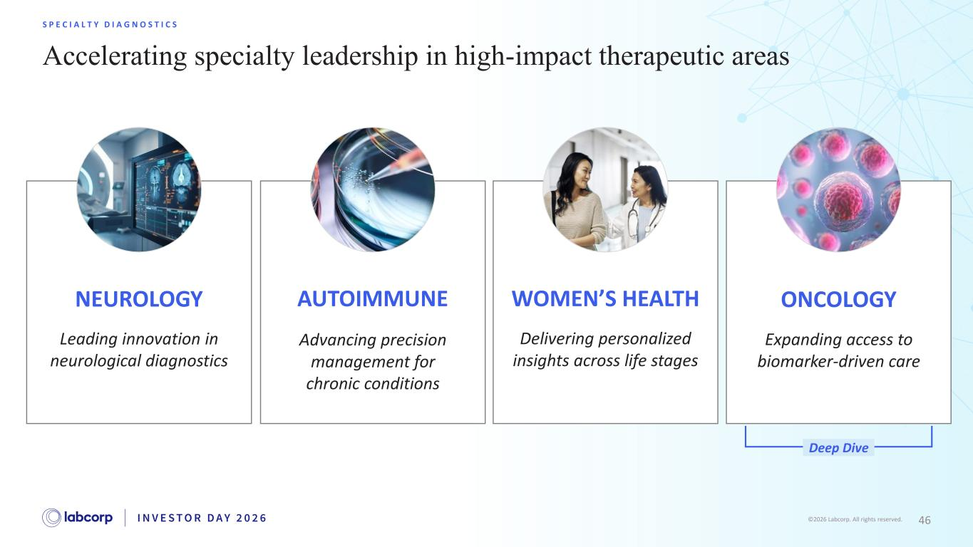
46©2026 Labcorp. All rights reserved. NEUROLOGY Leading innovation in neurological diagnostics Expanding access to biomarker-driven care ONCOLOGY Deep Dive WOMEN’S HEALTH Delivering personalized insights across life stages AUTOIMMUNE Advancing precision management for chronic conditions Accelerating specialty leadership in high-impact therapeutic areas S P E C I A L T Y D I A G N O S T I C S

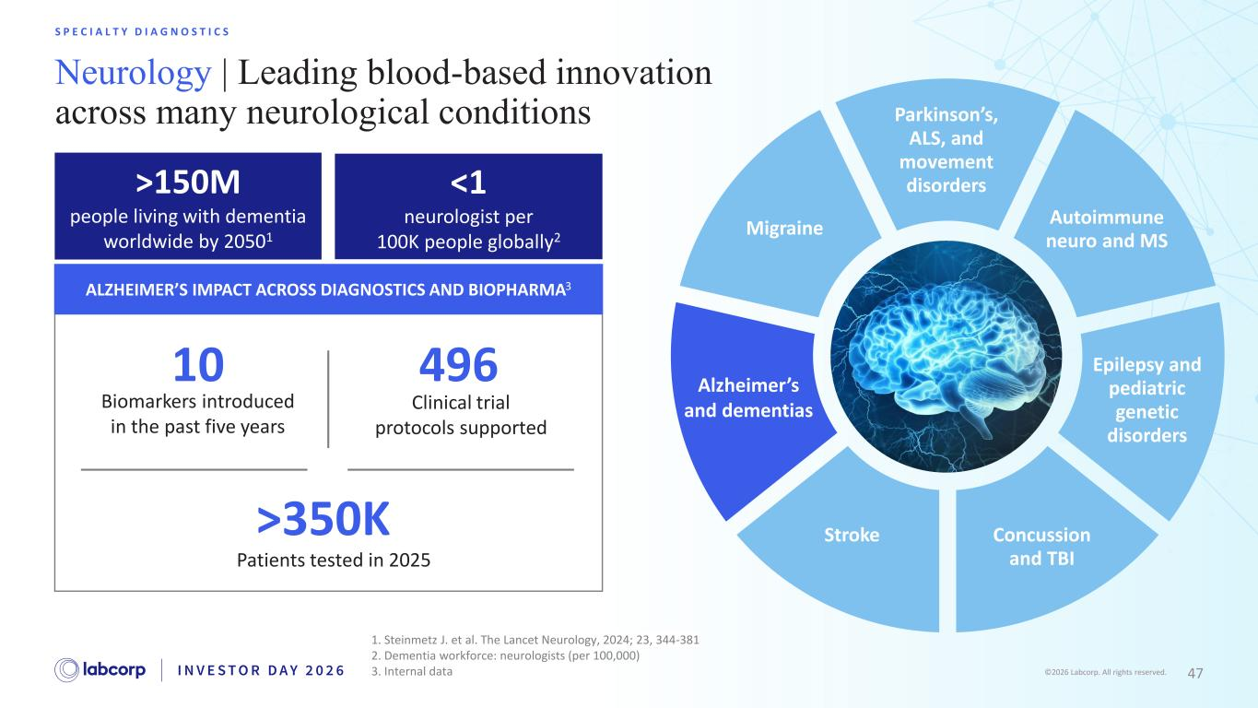
47©2026 Labcorp. All rights reserved. S P E C I A L T Y D I A G N O S T I C S Neurology | Leading blood-based innovation across many neurological conditions Parkinson’s, ALS, and movement disorders Autoimmune neuro and MS Epilepsy and pediatric genetic disorders Concussion and TBI Stroke Migraine Alzheimer’s and dementias <1 neurologist per 100K people globally2 ALZHEIMER’S IMPACT ACROSS DIAGNOSTICS AND BIOPHARMA3 >150M people living with dementia worldwide by 20501 1. Steinmetz J. et al. The Lancet Neurology, 2024; 23, 344-381 2. Dementia workforce: neurologists (per 100,000) 3. Internal data Biomarkers introduced in the past five years 10 Patients tested in 2025 >350K Clinical trial protocols supported 496

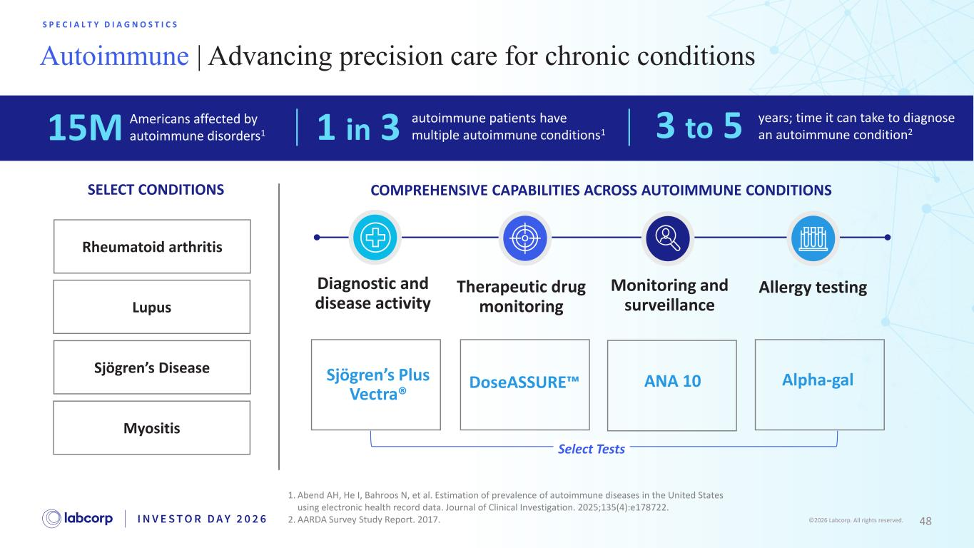
48©2026 Labcorp. All rights reserved. Rheumatoid arthritis S P E C I A L T Y D I A G N O S T I C S SELECT CONDITIONS Diagnostic and disease activity Therapeutic drug monitoring Monitoring and surveillanceLupus Sjögren’s Disease Myositis 1. Abend AH, He I, Bahroos N, et al. Estimation of prevalence of autoimmune diseases in the United States using electronic health record data. Journal of Clinical Investigation. 2025;135(4):e178722. 2. AARDA Survey Study Report. 2017. Autoimmune | Advancing precision care for chronic conditions DoseASSURE Allergy testing 15M Americans affected by autoimmune disorders1 1 in 3 autoimmune patients have multiple autoimmune conditions1 3 to 5 years; time it can take to diagnose an autoimmune condition2 Sjögren’s Plus Vectra® COMPREHENSIVE CAPABILITIES ACROSS AUTOIMMUNE CONDITIONS Alpha-galANA 10 Select Tests

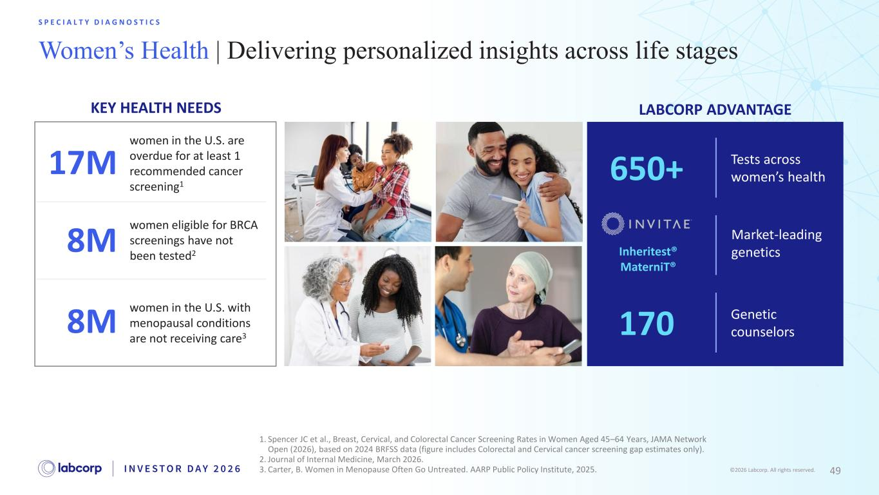
49©2026 Labcorp. All rights reserved. Women’s Health | Delivering personalized insights across life stages S P E C I A L T Y D I A G N O S T I C S 1. Spencer JC et al., Breast, Cervical, and Colorectal Cancer Screening Rates in Women Aged 45–64 Years, JAMA Network Open (2026), based on 2024 BRFSS data (figure includes Colorectal and Cervical cancer screening gap estimates only). 2. Journal of Internal Medicine, March 2026. 3. Carter, B. Women in Menopause Often Go Untreated. AARP Public Policy Institute, 2025. Market-leading genetics8M women eligible for BRCA screenings have not been tested2 17M women in the U.S. are overdue for at least 1 recommended cancer screening1 8M women in the U.S. with menopausal conditions are not receiving care3 KEY HEALTH NEEDS LABCORP ADVANTAGE 650+ Tests across women’s health Genetic counselors 170 Inheritest® MaterniT® Market-leading genetics


50©2026 Labcorp. All rights reserved. Oncology Deep Dive

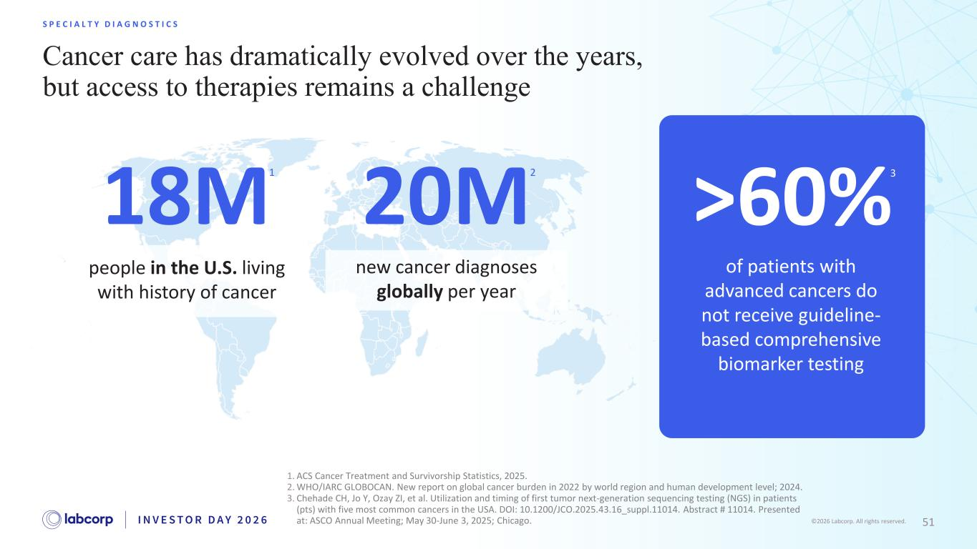
51©2026 Labcorp. All rights reserved. Cancer care has dramatically evolved over the years, but access to therapies remains a challenge S P E C I A L T Y D I A G N O S T I C S people in the U.S. living with history of cancer 18M new cancer diagnoses globally per year 20M of patients with advanced cancers do not receive guideline- based comprehensive biomarker testing >60% 1. ACS Cancer Treatment and Survivorship Statistics, 2025. 2. WHO/IARC GLOBOCAN. New report on global cancer burden in 2022 by world region and human development level; 2024. 3. Chehade CH, Jo Y, Ozay ZI, et al. Utilization and timing of first tumor next-generation sequencing testing (NGS) in patients (pts) with five most common cancers in the USA. DOI: 10.1200/JCO.2025.43.16_suppl.11014. Abstract # 11014. Presented at: ASCO Annual Meeting; May 30-June 3, 2025; Chicago. 1 2 3

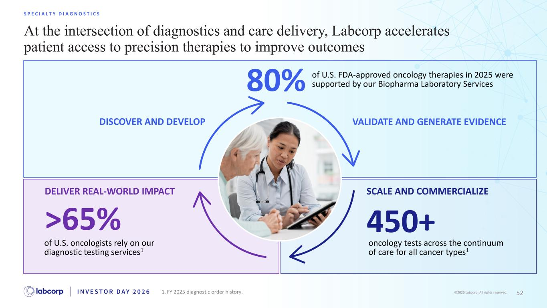
52©2026 Labcorp. All rights reserved. At the intersection of diagnostics and care delivery, Labcorp accelerates patient access to precision therapies to improve outcomes S P E C I A L T Y D I A G N O S T I C S DISCOVER AND DEVELOP of U.S. FDA-approved oncology therapies in 2025 were supported by our Biopharma Laboratory Services80% VALIDATE AND GENERATE EVIDENCE SCALE AND COMMERCIALIZE oncology tests across the continuum of care for all cancer types1 450+ DELIVER REAL-WORLD IMPACT of U.S. oncologists rely on our diagnostic testing services1 >65% 1. FY 2025 diagnostic order history.

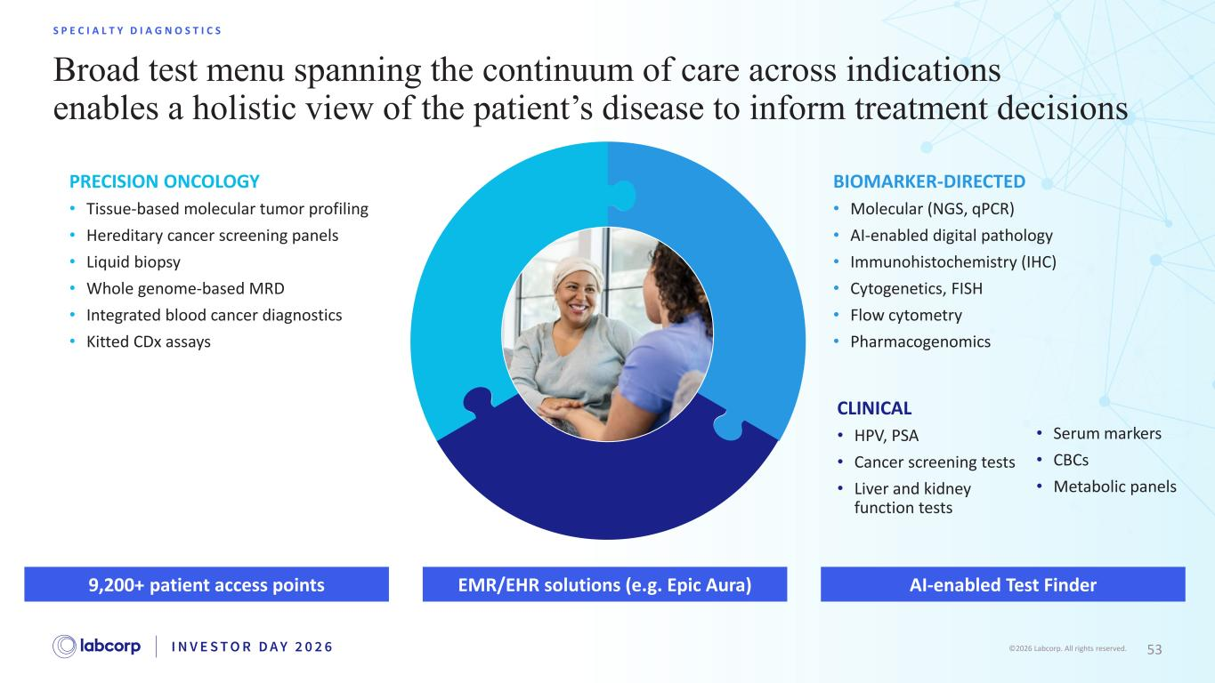
53©2026 Labcorp. All rights reserved. Broad test menu spanning the continuum of care across indications enables a holistic view of the patient’s disease to inform treatment decisions S P E C I A L T Y D I A G N O S T I C S PRECISION ONCOLOGY • Tissue-based molecular tumor profiling • Hereditary cancer screening panels • Liquid biopsy • Whole genome-based MRD • Integrated blood cancer diagnostics • Kitted CDx assays BIOMARKER-DIRECTED • Molecular (NGS, qPCR) • AI-enabled digital pathology • Immunohistochemistry (IHC) • Cytogenetics, FISH • Flow cytometry • Pharmacogenomics CLINICAL • HPV, PSA • Cancer screening tests • Liver and kidney function tests EMR/EHR solutions (e.g. Epic Aura) AI-enabled Test Finder9,200+ patient access points • Serum markers • CBCs • Metabolic panels

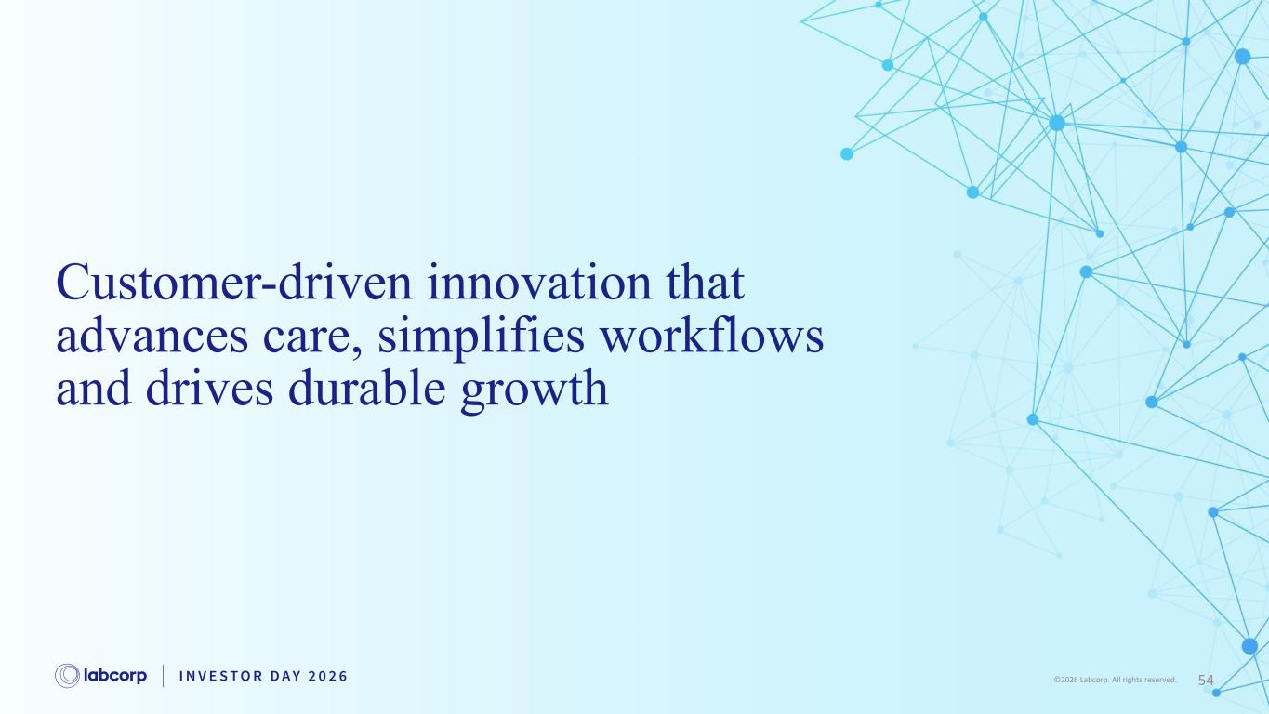
54©2026 Labcorp. All rights reserved. Customer-driven innovation that advances care, simplifies workflows and drives durable growth

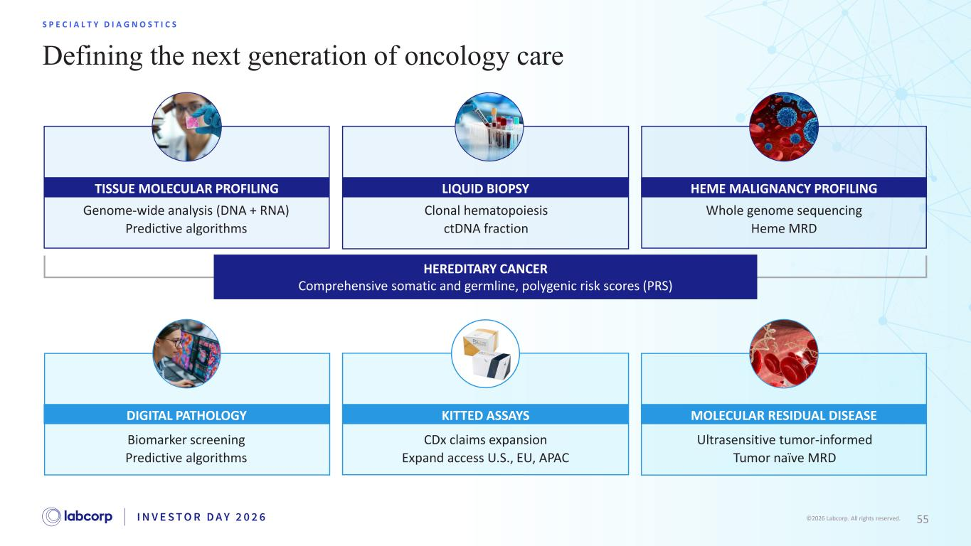
55©2026 Labcorp. All rights reserved. Defining the next generation of oncology care S P E C I A L T Y D I A G N O S T I C S Genome-wide analysis (DNA + RNA) Predictive algorithms TISSUE MOLECULAR PROFILING Whole genome sequencing Heme MRD HEME MALIGNANCY PROFILING Biomarker screening Predictive algorithms DIGITAL PATHOLOGY Ultrasensitive tumor-informed Tumor naïve MRD MOLECULAR RESIDUAL DISEASE CDx claims expansion Expand access U.S., EU, APAC KITTED ASSAYS HEREDITARY CANCER Comprehensive somatic and germline, polygenic risk scores (PRS) Clonal hematopoiesis ctDNA fraction LIQUID BIOPSY

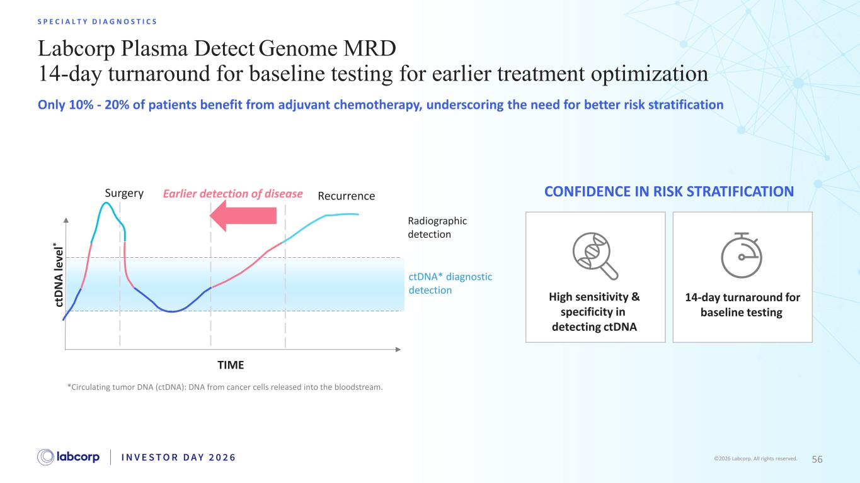
56©2026 Labcorp. All rights reserved. Labcorp Plasma Detect Genome MRD 14-day turnaround for baseline testing for earlier treatment optimization S P E C I A L T Y D I A G N O S T I C S Only 10% - 20% of patients benefit from adjuvant chemotherapy, underscoring the need for better risk stratification *Circulating tumor DNA (ctDNA): DNA from cancer cells released into the bloodstream. Radiographic detection ctDNA* diagnostic detection Surgery Recurrence TIME ct D N A le ve l* Earlier detection of disease High sensitivity & specificity in detecting ctDNA 14-day turnaround for baseline testing CONFIDENCE IN RISK STRATIFICATION

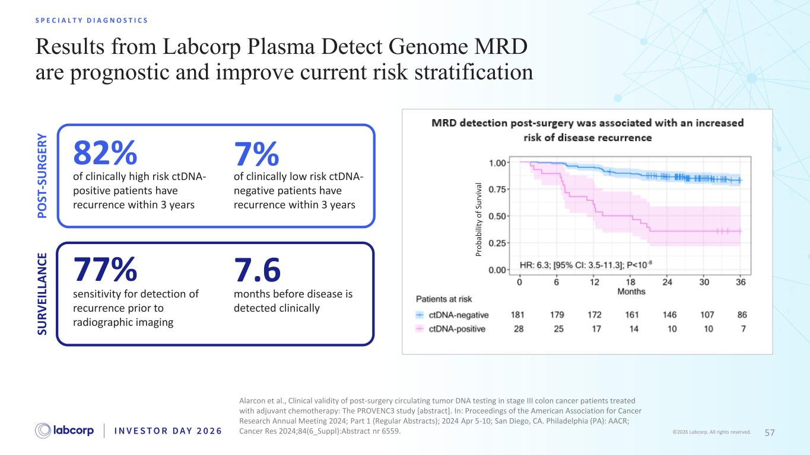
57©2026 Labcorp. All rights reserved. Results from Labcorp Plasma Detect Genome MRD are prognostic and improve current risk stratification S P E C I A L T Y D I A G N O S T I C S Alarcon et al., Clinical validity of post-surgery circulating tumor DNA testing in stage III colon cancer patients treated with adjuvant chemotherapy: The PROVENC3 study [abstract]. In: Proceedings of the American Association for Cancer Research Annual Meeting 2024; Part 1 (Regular Abstracts); 2024 Apr 5-10; San Diego, CA. Philadelphia (PA): AACR; Cancer Res 2024;84(6_Suppl):Abstract nr 6559. P ro b ab ili ty o f Su rv iv al 77% sensitivity for detection of recurrence prior to radiographic imaging 7.6 months before disease is detected clinically 82% of clinically high risk ctDNA- positive patients have recurrence within 3 years of clinically low risk ctDNA- negative patients have recurrence within 3 years 7% P O ST -S U R G ER Y SU R V EI LL A N C E

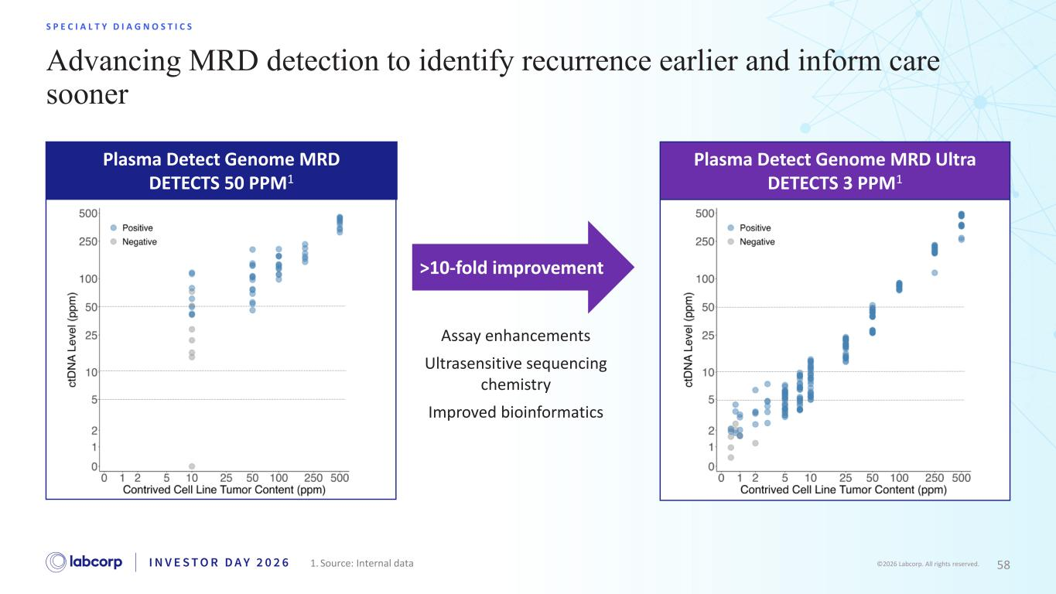
58©2026 Labcorp. All rights reserved. Advancing MRD detection to identify recurrence earlier and inform care sooner S P E C I A L T Y D I A G N O S T I C S Assay enhancements Ultrasensitive sequencing chemistry Improved bioinformatics Plasma Detect Genome MRD DETECTS 50 PPM1 Plasma Detect Genome MRD Ultra DETECTS 3 PPM1 >10-fold improvement 1. Source: Internal data

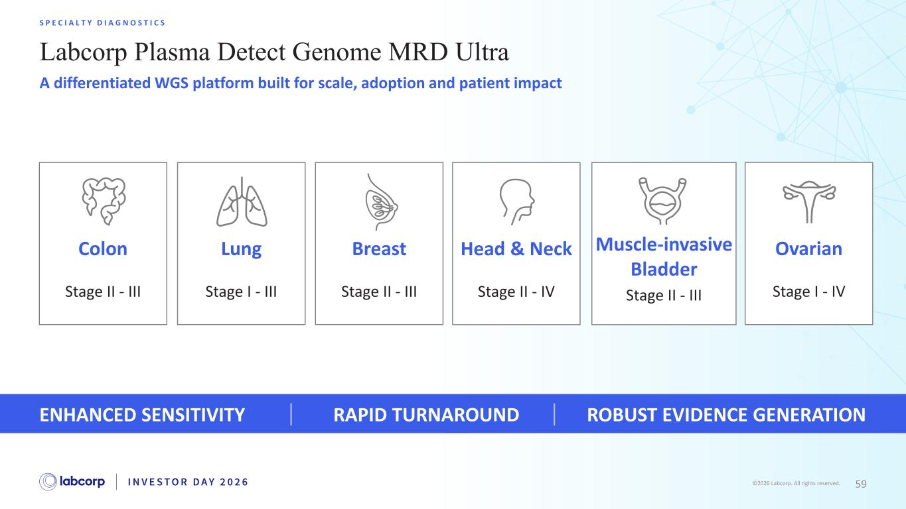
59©2026 Labcorp. All rights reserved. Labcorp Plasma Detect Genome MRD Ultra S P E C I A L T Y D I A G N O S T I C S A differentiated WGS platform built for scale, adoption and patient impact Colon Stage II - III Lung Stage I - III Head & Neck Stage II - IV Muscle-invasive Bladder Stage II - III Ovarian Stage I - IV Breast Stage II - III ENHANCED SENSITIVITY RAPID TURNAROUND ROBUST EVIDENCE GENERATION

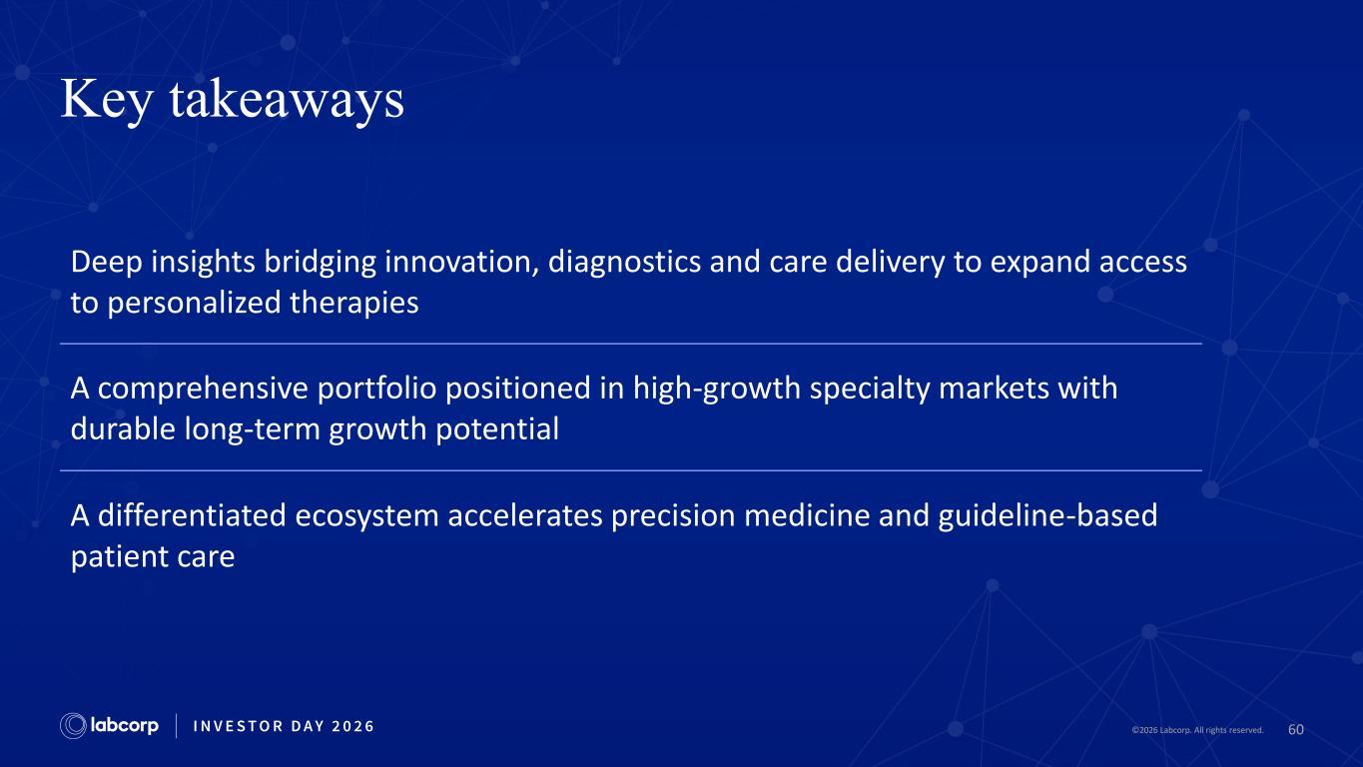
60©2026 Labcorp. All rights reserved. Key takeaways Deep insights bridging innovation, diagnostics and care delivery to expand access to personalized therapies A comprehensive portfolio positioned in high-growth specialty markets with durable long-term growth potential A differentiated ecosystem accelerates precision medicine and guideline-based patient care

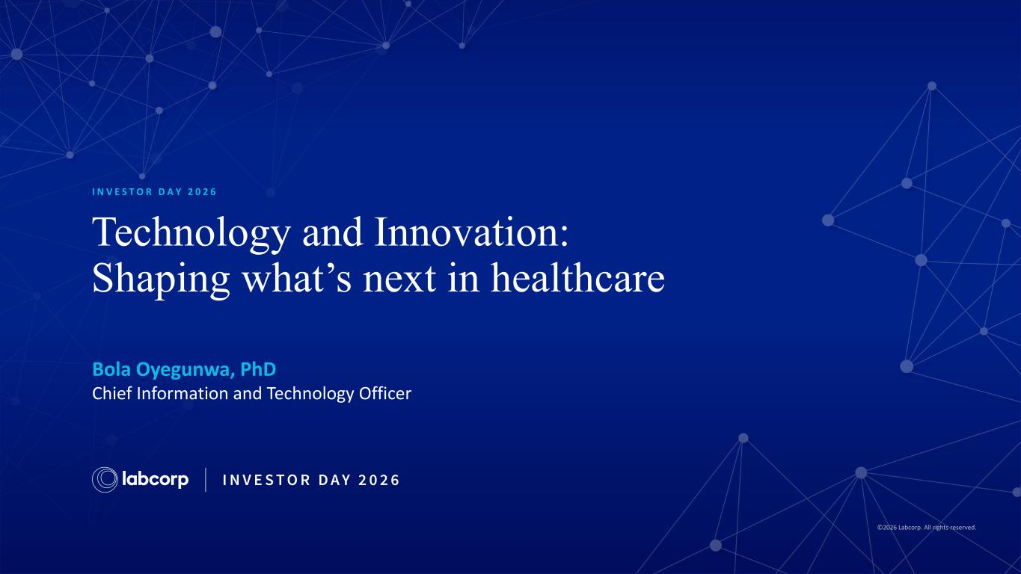
©2026 Labcorp. All rights reserved. Technology and Innovation: Shaping what’s next in healthcare Bola Oyegunwa, PhD Chief Information and ​Technology Officer​ I N V E S T O R D A Y 2 0 2 6

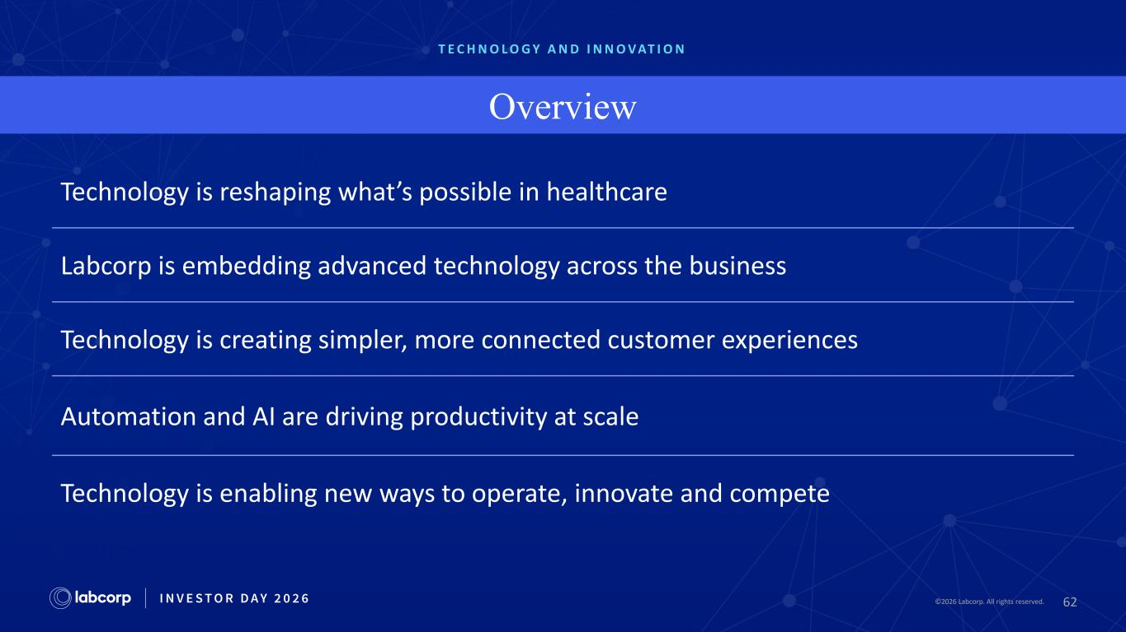
62©2026 Labcorp. All rights reserved.2026 Labcorp. All rights reserved. T E C H N O L O G Y A N D I N N O V AT I O N Overview Technology is reshaping what’s possible in healthcare Labcorp is embedding advanced technology across the business Technology is creating simpler, more connected customer experiences Automation and AI are driving productivity at scale Technology is enabling new ways to operate, innovate and compete

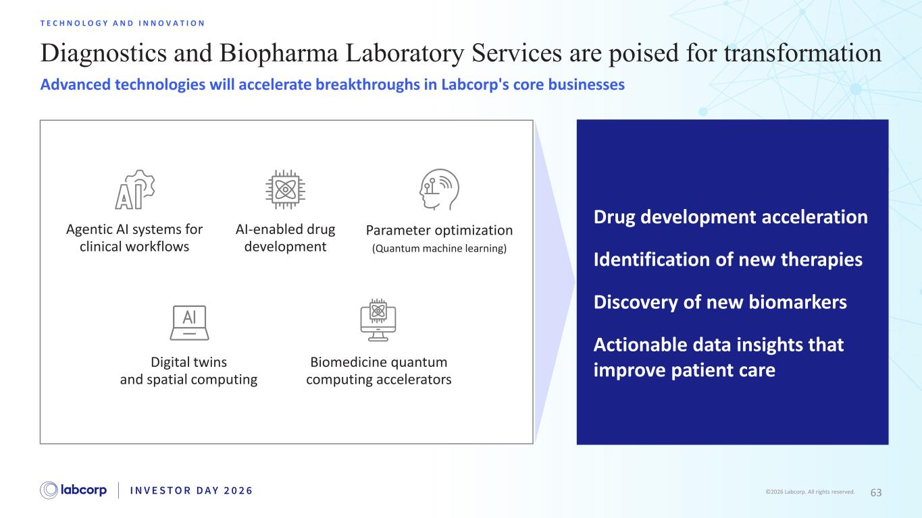
63©2026 Labcorp. All rights reserved. Diagnostics and Biopharma Laboratory Services are poised for transformation T E C H N O L O G Y A N D I N N O V A T I O N Advanced technologies will accelerate breakthroughs in Labcorp's core businesses Drug development acceleration Identification of new therapies Discovery of new biomarkers Actionable data insights that improve patient care Agentic AI systems for clinical workflows AI-enabled drug development Parameter optimization (Quantum machine learning) Digital twins and spatial computing Biomedicine quantum computing accelerators

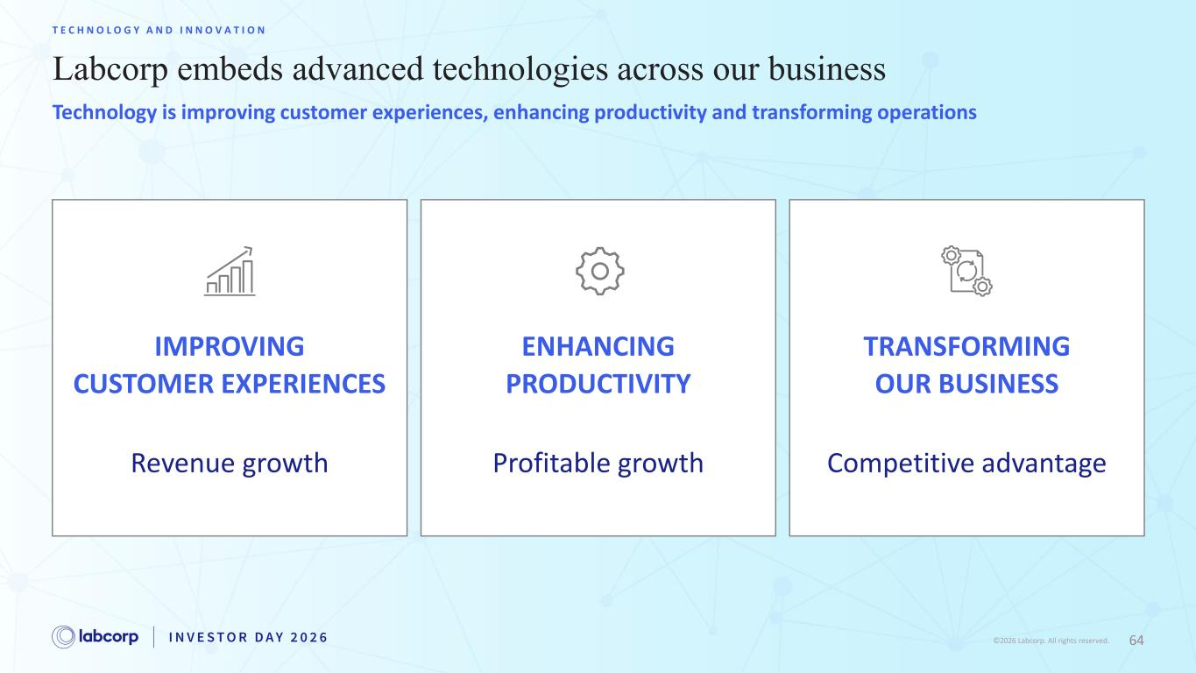
64©2026 Labcorp. All rights reserved. Labcorp embeds advanced technologies across our business T E C H N O L O G Y A N D I N N O V A T I O N Technology is improving customer experiences, enhancing productivity and transforming operations IMPROVING CUSTOMER EXPERIENCES Revenue growth ENHANCING PRODUCTIVITY Profitable growth TRANSFORMING OUR BUSINESS Competitive advantage

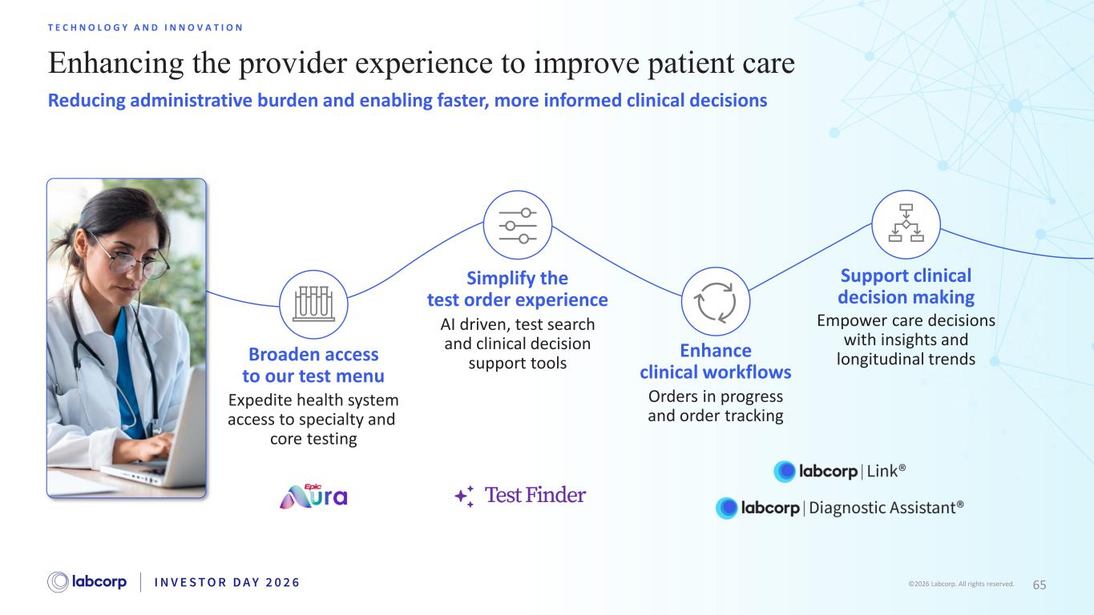
65©2026 Labcorp. All rights reserved. Enhancing the provider experience to improve patient care T E C H N O L O G Y A N D I N N O V A T I O N Reducing administrative burden and enabling faster, more informed clinical decisions Support clinical decision making Empower care decisions with insights and longitudinal trendsEnhance clinical workflows Orders in progress and order tracking Simplify the test order experience AI driven, test search and clinical decision support toolsBroaden access to our test menu Expedite health system access to specialty and core testing

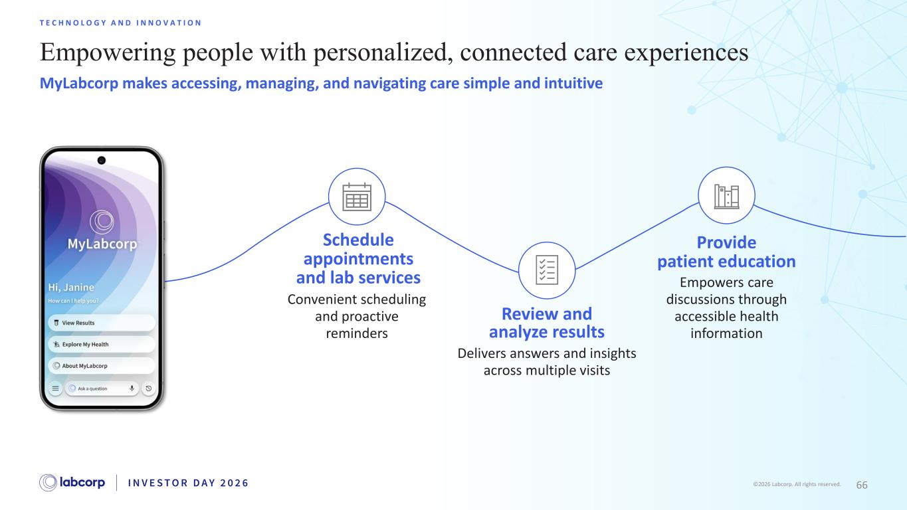
66©2026 Labcorp. All rights reserved. Empowering people with personalized, connected care experiences T E C H N O L O G Y A N D I N N O V A T I O N MyLabcorp makes accessing, managing, and navigating care simple and intuitive Provide patient education Empowers care discussions through accessible health information Review and analyze results Delivers answers and insights across multiple visits Schedule appointments and lab services Convenient scheduling and proactive reminders

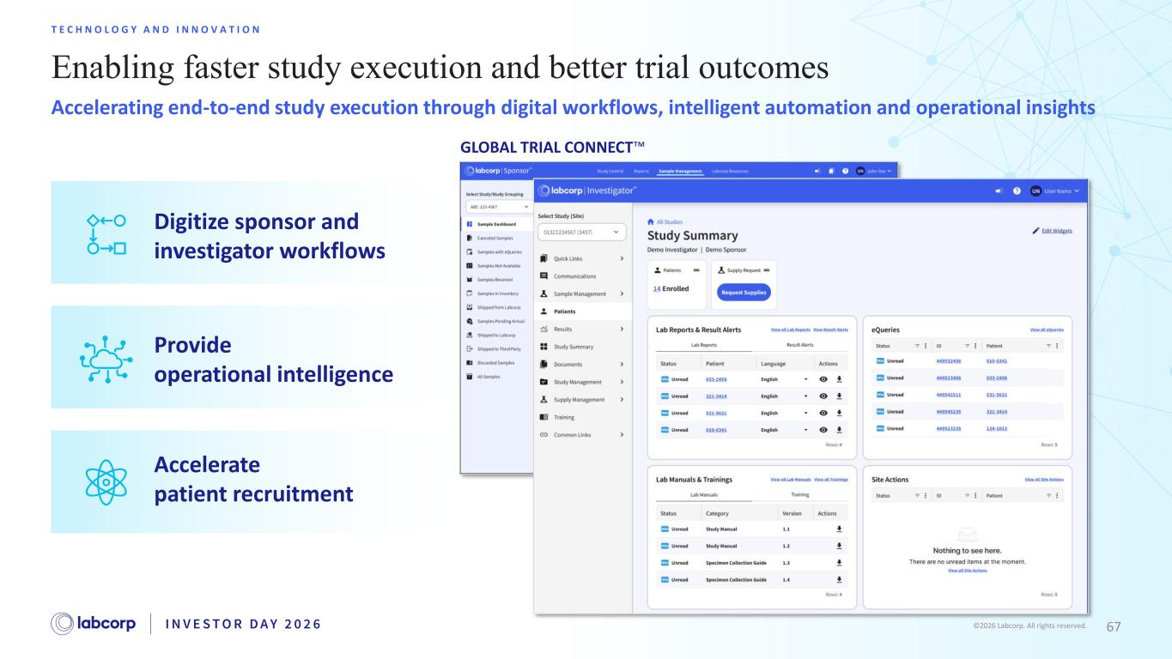
67©2026 Labcorp. All rights reserved. Enabling faster study execution and better trial outcomes T E C H N O L O G Y A N D I N N O V A T I O N Accelerating end-to-end study execution through digital workflows, intelligent automation and operational insights Digitize sponsor and investigator workflows Provide operational intelligence Accelerate patient recruitment GLOBAL TRIAL CONNECT

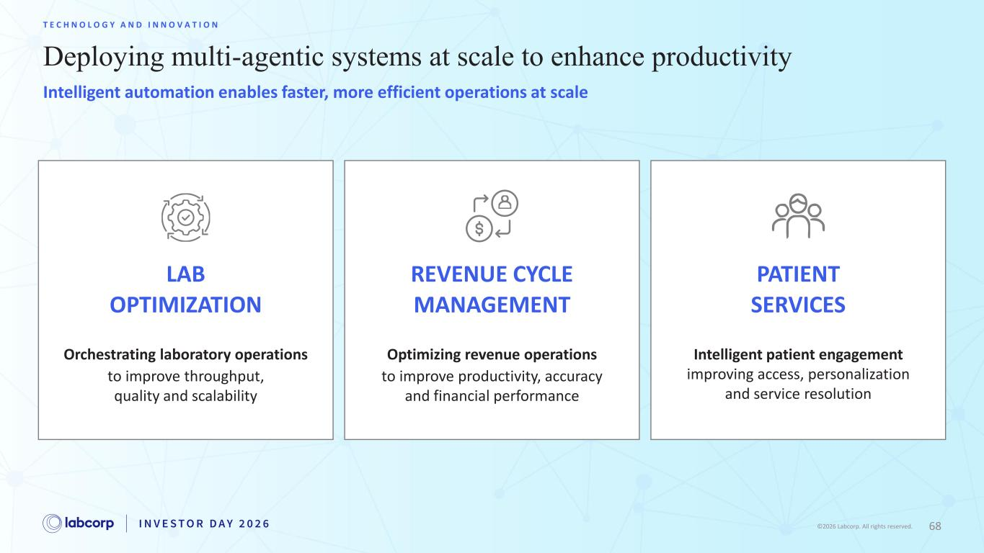
68©2026 Labcorp. All rights reserved. Deploying multi-agentic systems at scale to enhance productivity T E C H N O L O G Y A N D I N N O V A T I O N LAB OPTIMIZATION REVENUE CYCLE MANAGEMENT PATIENT SERVICES Orchestrating laboratory operations to improve throughput, quality and scalability Optimizing revenue operations to improve productivity, accuracy and financial performance Intelligent patient engagement improving access, personalization and service resolution Intelligent automation enables faster, more efficient operations at scale

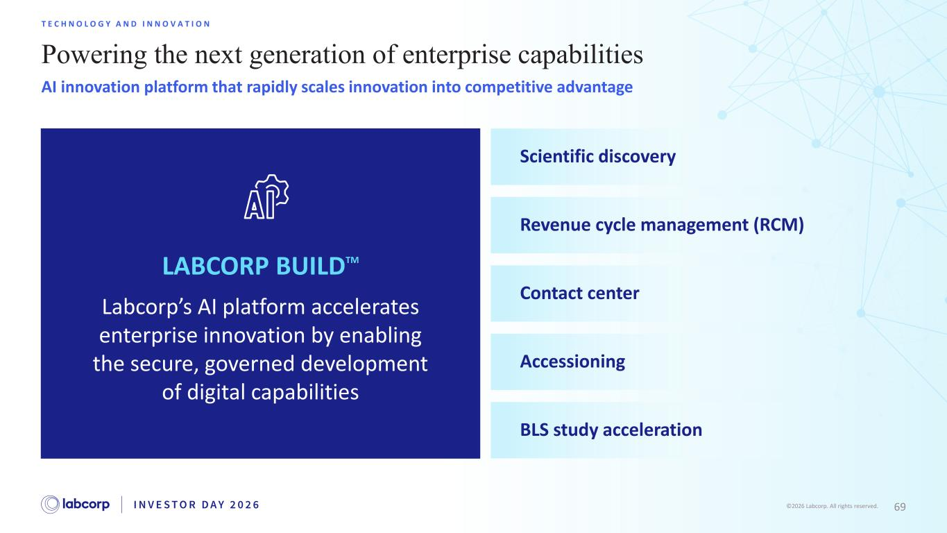
69©2026 Labcorp. All rights reserved. Powering the next generation of enterprise capabilities T E C H N O L O G Y A N D I N N O V A T I O N AI innovation platform that rapidly scales innovation into competitive advantage Labcorp’s AI platform accelerates enterprise innovation by enabling the secure, governed development of digital capabilities Scientific discovery Revenue cycle management (RCM) Contact center Accessioning BLS study acceleration LABCORP BUILDTM

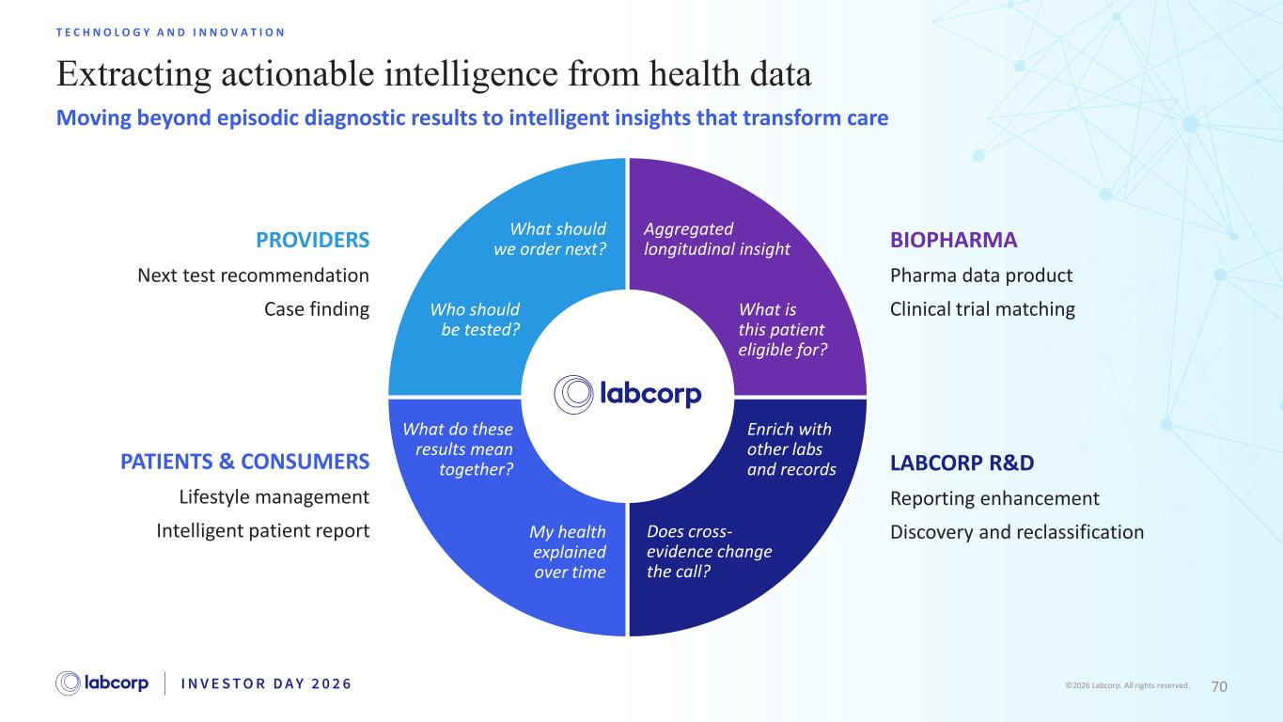
70©2026 Labcorp. All rights reserved. Extracting actionable intelligence from health data T E C H N O L O G Y A N D I N N O V A T I O N Moving beyond episodic diagnostic results to intelligent insights that transform care What is this patient eligible for? Aggregated longitudinal insight Does cross- evidence change the call? Enrich with other labs and records BIOPHARMA Pharma data product Clinical trial matching PATIENTS & CONSUMERS Lifestyle management Intelligent patient report PROVIDERS Next test recommendation Case finding LABCORP R&D Reporting enhancement Discovery and reclassificationMy health explained over time What do these results mean together? What should we order next? Who should be tested?

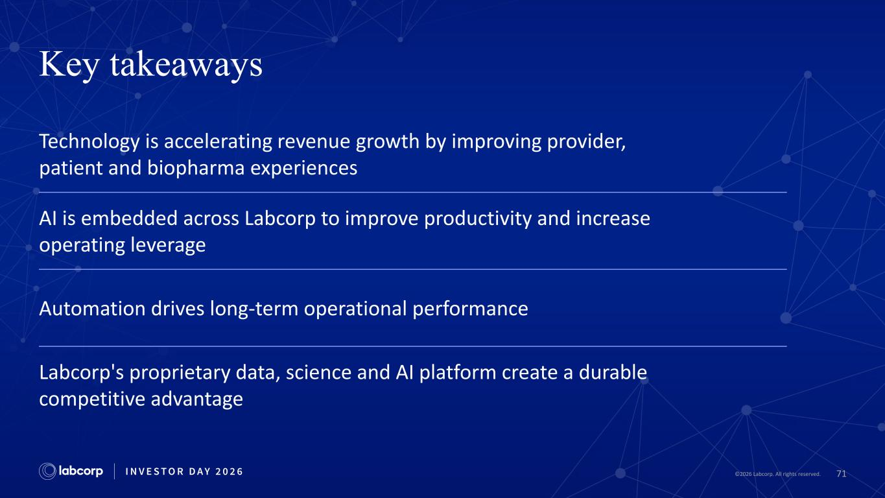
71©2026 Labcorp. All rights reserved. Key takeaways Technology is accelerating revenue growth by improving provider, patient and biopharma experiences AI is embedded across Labcorp to improve productivity and increase operating leverage Automation drives long-term operational performance Labcorp's proprietary data, science and AI platform create a durable competitive advantage


©2026 Labcorp. All rights reserved. Long-Term Financial Outlook Julia Wang Chief Financial Officer I N V E S T O R D A Y 2 0 2 6

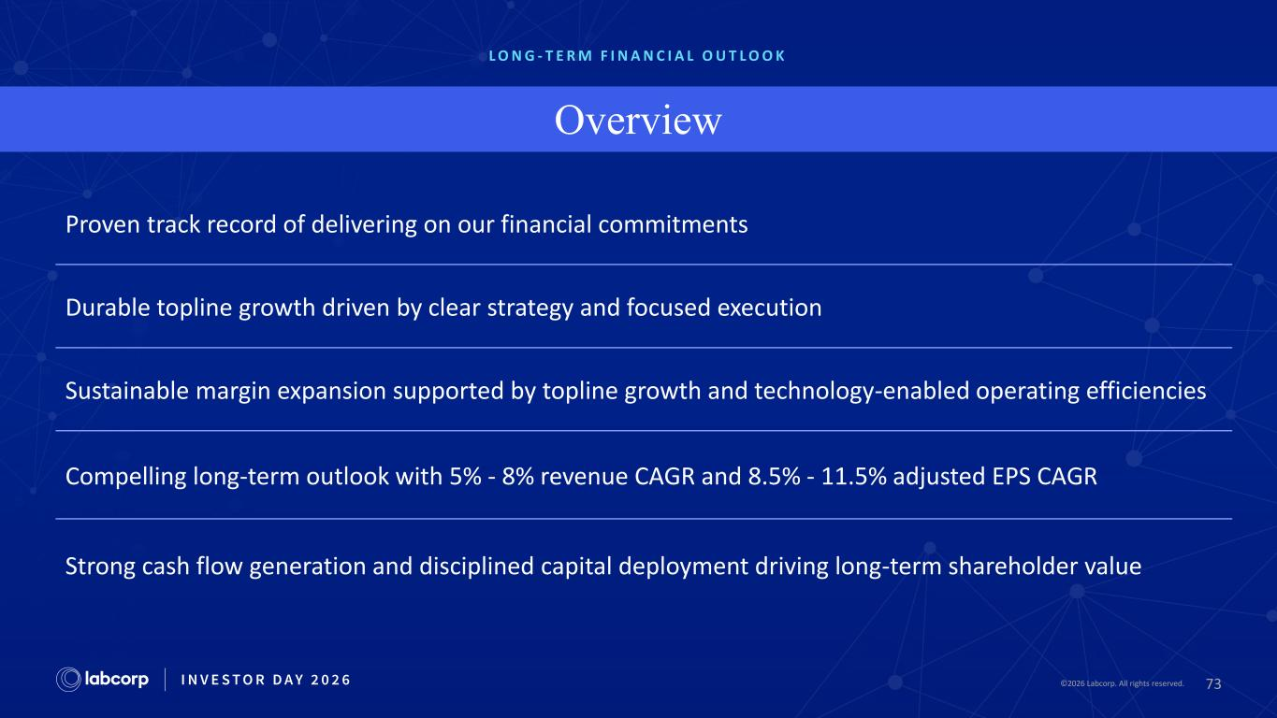
73©2026 Labcorp. All rights reserved.2026 Labcorp. All rights reserved. L O N G - T E R M F I N A N C I A L O U T L O O K Overview Proven track record of delivering on our financial commitments Durable topline growth driven by clear strategy and focused execution Sustainable margin expansion supported by topline growth and technology-enabled operating efficiencies Compelling long-term outlook with 5% - 8% revenue CAGR and 8.5% - 11.5% adjusted EPS CAGR Strong cash flow generation and disciplined capital deployment driving long-term shareholder value

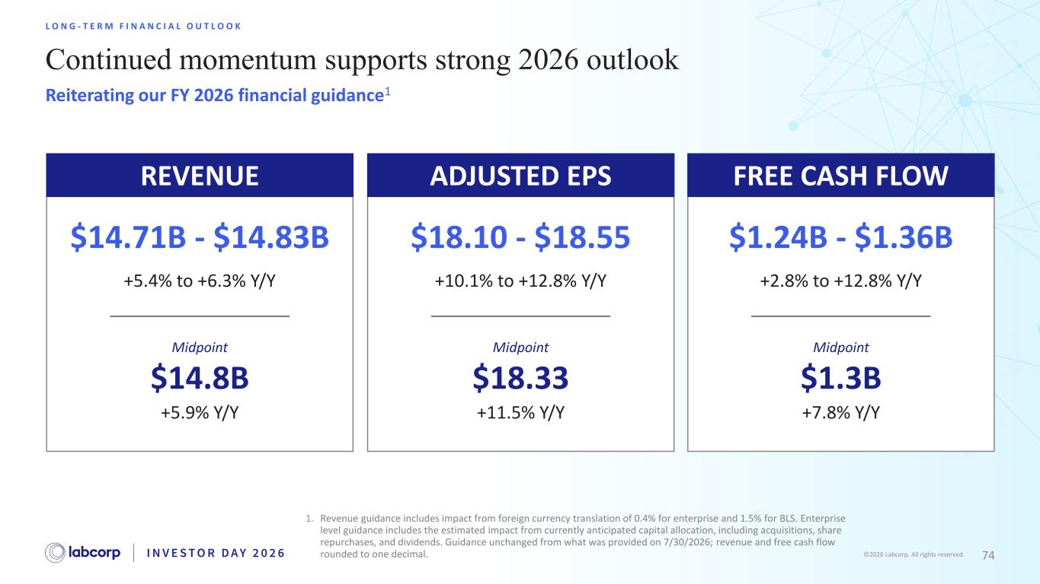
74©2026 Labcorp. All rights reserved. Continued momentum supports strong 2026 outlook L O N G - T E R M F I N A N C I A L O U T L O O K Reiterating our FY 2026 financial guidance1 1. Revenue guidance includes impact from foreign currency translation of 0.4% for enterprise and 1.5% for BLS. ​Enterprise level guidance includes the estimated impact from currently anticipated capital allocation, including acquisitions, share repurchases, and dividends. Guidance unchanged from what was provided on 7/30/2026; revenue and free cash flow rounded to one decimal. $14.71B - $14.83B +5.4% to +6.3% Y/Y +5.9% Y/Y $14.8B Midpoint ADJUSTED EPS $18.10 - $18.55 +10.1% to +12.8% Y/Y +11.5% Y/Y $18.33 Midpoint FREE CASH FLOW $1.24B - $1.36B +2.8% to +12.8% Y/Y +7.8% Y/Y $1.3B Midpoint REVENUE

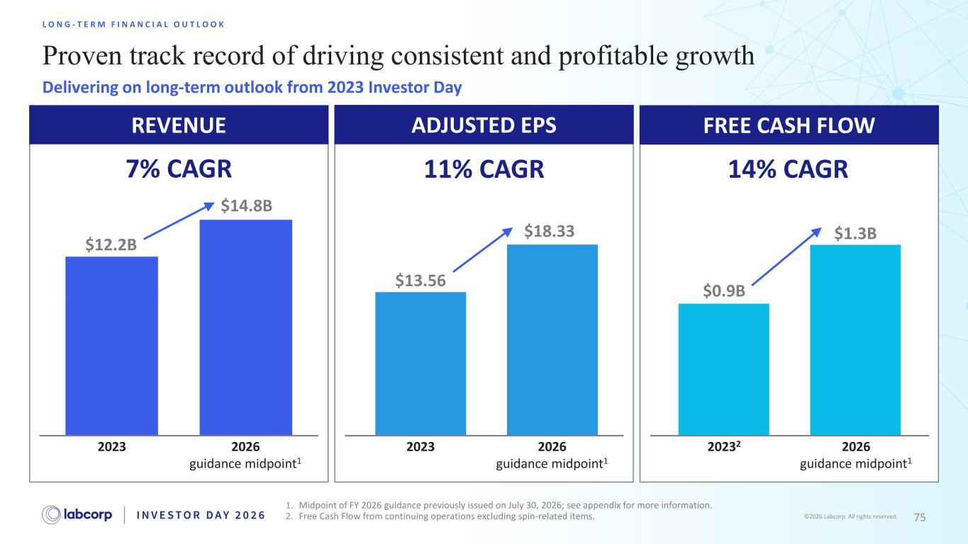
75©2026 Labcorp. All rights reserved. Proven track record of driving consistent and profitable growth L O N G - T E R M F I N A N C I A L O U T L O O K Delivering on long-term outlook from 2023 Investor Day 1. Midpoint of FY 2026 guidance previously issued on July 30, 2026; see appendix for more information. 2. Free Cash Flow from continuing operations excluding spin-related items. ADJUSTED EPS 2023 $13.56 $18.33 2026 guidance midpoint1 11% CAGR FREE CASH FLOW 20232 $1.3B 2026 guidance midpoint1 14% CAGR $0.9B REVENUE 2026 guidance midpoint1 2023 $14.8B 7% CAGR $12.2B

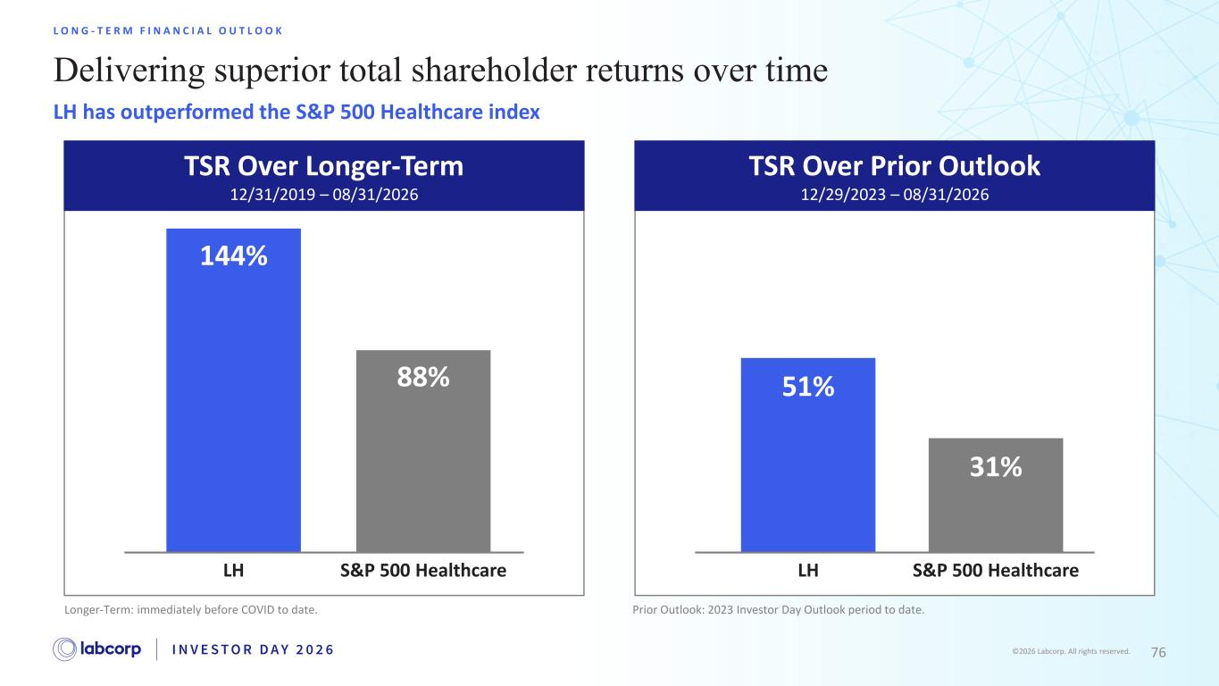
76©2026 Labcorp. All rights reserved. TSR Over Prior Outlook 12/29/2023 – 08/31/2026 TSR Over Longer-Term 12/31/2019 – 08/31/2026 Delivering superior total shareholder returns over time L O N G - T E R M F I N A N C I A L O U T L O O K LH has outperformed the S&P 500 Healthcare index LH S&P 500 Healthcare LH S&P 500 Healthcare 144% 88% 51% 31% Longer-Term: immediately before COVID to date. Prior Outlook: 2023 Investor Day Outlook period to date.

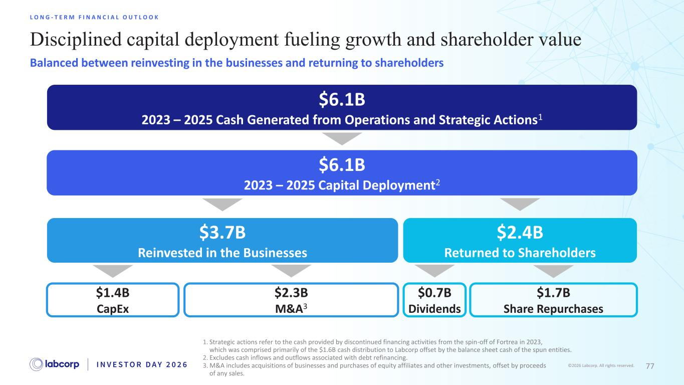
77©2026 Labcorp. All rights reserved. Disciplined capital deployment fueling growth and shareholder value L O N G - T E R M F I N A N C I A L O U T L O O K 1. Strategic actions refer to the cash provided by discontinued financing activities from the spin-off of Fortrea in 2023, which was comprised primarily of the $1.6B cash distribution to Labcorp offset by the balance sheet cash of the spun entities. 2. Excludes cash inflows and outflows associated with debt refinancing. 3. M&A includes acquisitions of businesses and purchases of equity affiliates and other investments, offset by proceeds of any sales. $6.1B 2023 – 2025 Capital Deployment2 $3.7B Reinvested in the Businesses $2.4B Returned to Shareholders $1.4B CapEx $2.3B M&A3 $0.7B Dividends $1.7B Share Repurchases $6.1B 2023 – 2025 Cash Generated from Operations and Strategic Actions1 Balanced between reinvesting in the businesses and returning to shareholders

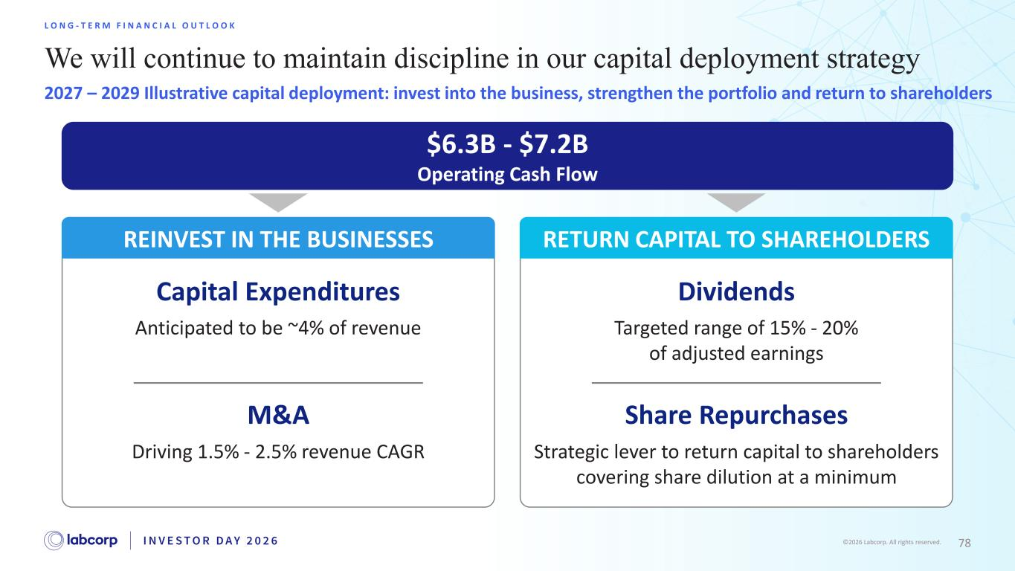
78©2026 Labcorp. All rights reserved. We will continue to maintain discipline in our capital deployment strategy L O N G - T E R M F I N A N C I A L O U T L O O K 2027 – 2029 Illustrative capital deployment: invest into the business, strengthen the portfolio and return to shareholders $6.3B - $7.2B Operating Cash Flow Capital Expenditures Anticipated to be ~4% of revenue M&A Driving 1.5% - 2.5% revenue CAGR REINVEST IN THE BUSINESSES RETURN CAPITAL TO SHAREHOLDERS Dividends Targeted range of 15% - 20% of adjusted earnings Share Repurchases Strategic lever to return capital to shareholders covering share dilution at a minimum

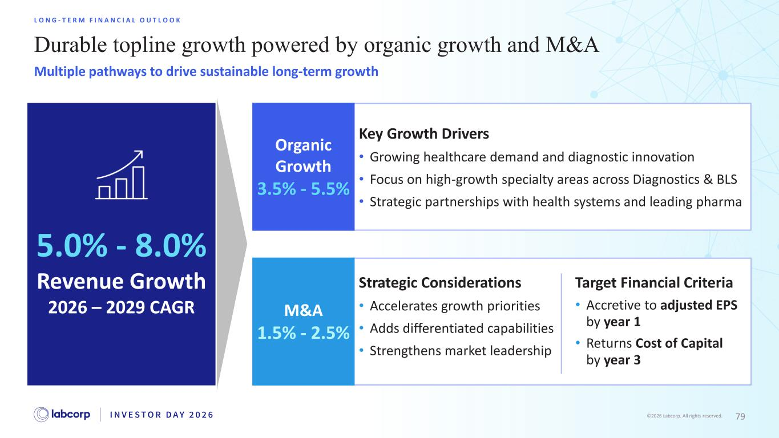
79©2026 Labcorp. All rights reserved. Durable topline growth powered by organic growth and M&A L O N G - T E R M F I N A N C I A L O U T L O O K Multiple pathways to drive sustainable long-term growth 5.0% - 8.0% Revenue Growth 2026 – 2029 CAGR Strategic Considerations • Accelerates growth priorities • Adds differentiated capabilities • Strengthens market leadership M&A 1.5% - 2.5% Target Financial Criteria • Accretive to adjusted EPS by year 1 • Returns Cost of Capital b by year 3 Key Growth Drivers • Growing healthcare demand and diagnostic innovation • Focus on high-growth specialty areas across Diagnostics & BLS • Strategic partnerships with health systems and leading pharma Organic Growth 3.5% - 5.5%

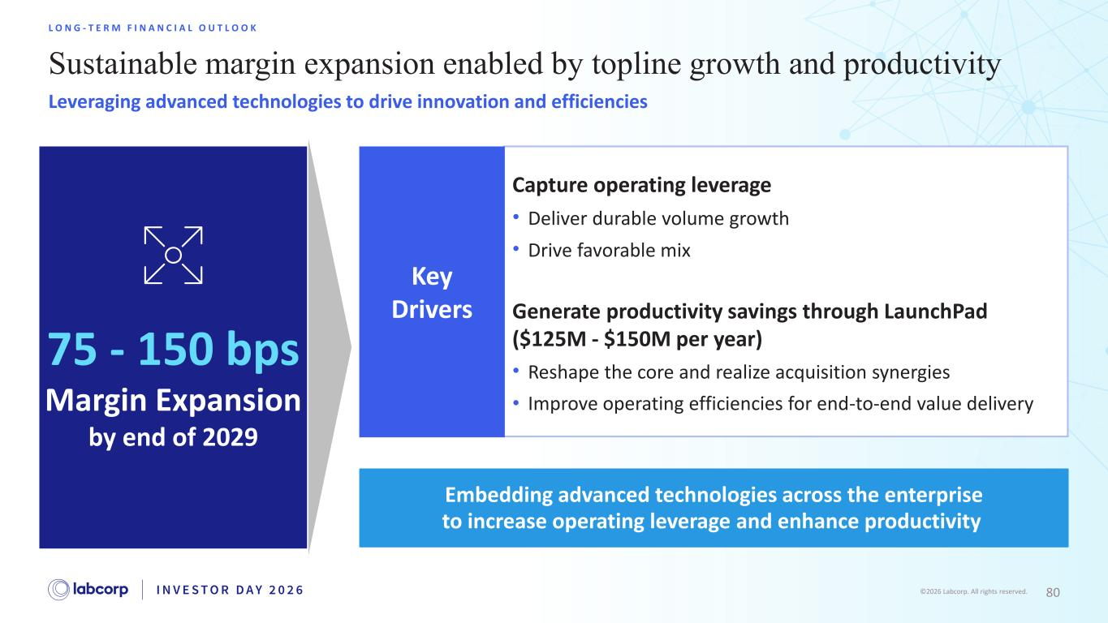
80©2026 Labcorp. All rights reserved. Sustainable margin expansion enabled by topline growth and productivity L O N G - T E R M F I N A N C I A L O U T L O O K Leveraging advanced technologies to drive innovation and efficiencies 75 - 150 bps Margin Expansion by end of 2029 Capture operating leverage • Deliver durable volume growth • Drive favorable mix Generate productivity savings through LaunchPad ($125M - $150M per year) • Reshape the core and realize acquisition synergies • Improve operating efficiencies for end-to-end value delivery Key Drivers Embedding advanced technologies across the enterprise to increase operating leverage and enhance productivity

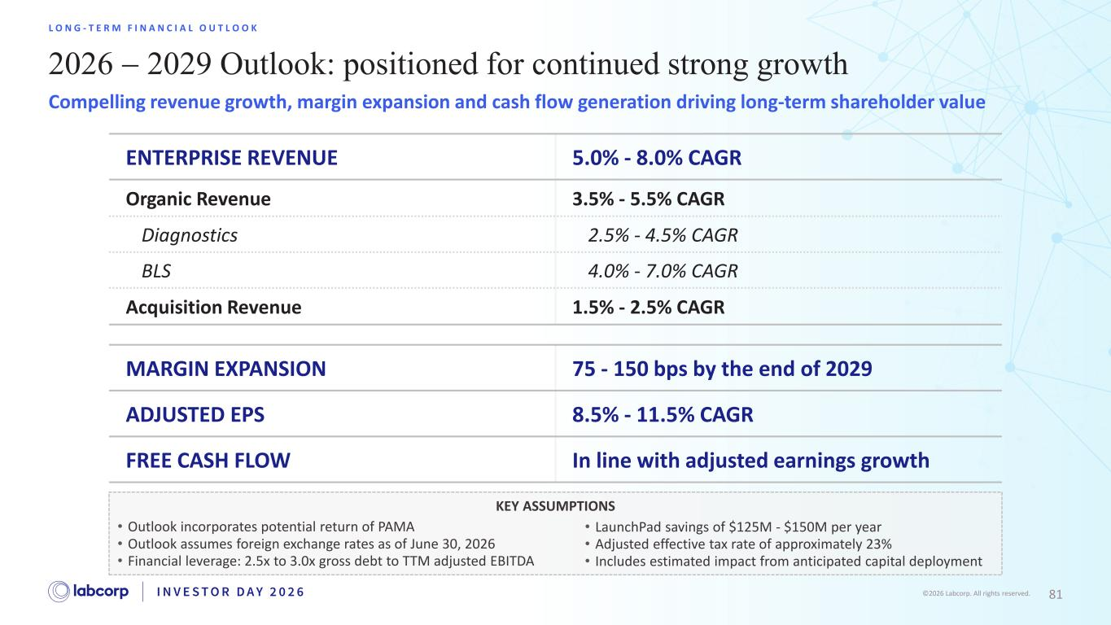
81©2026 Labcorp. All rights reserved. 2026 − 2029 Outlook: positioned for continued strong growth L O N G - T E R M F I N A N C I A L O U T L O O K Compelling revenue growth, margin expansion and cash flow generation driving long-term shareholder value MARGIN EXPANSION 75 - 150 bps by the end of 2029 ADJUSTED EPS 8.5% - 11.5% CAGR FREE CASH FLOW In line with adjusted earnings growth ENTERPRISE REVENUE 5.0% - 8.0% CAGR Organic Revenue 3.5% - 5.5% CAGR Diagnostics 2.5% - 4.5% CAGR BLS 4.0% - 7.0% CAGR Acquisition Revenue 1.5% - 2.5% CAGR KEY ASSUMPTIONS • Outlook incorporates potential return of PAMA • Outlook assumes foreign exchange rates as of June 30, 2026 • Financial leverage: 2.5x to 3.0x gross debt to TTM adjusted EBITDA • LaunchPad savings of $125M - $150M per year • Adjusted effective tax rate of approximately 23% • Includes estimated impact from anticipated capital deployment

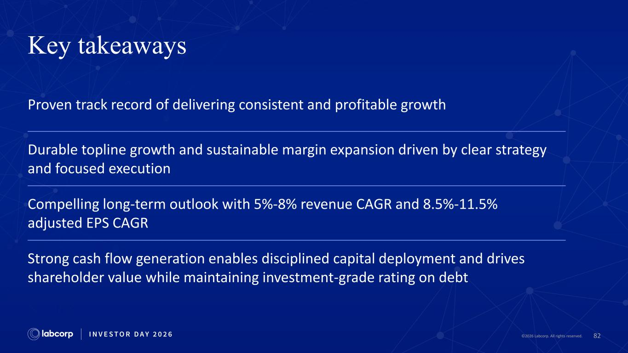
82©2026 Labcorp. All rights reserved. Key takeaways Proven track record of delivering consistent and profitable growth Durable topline growth and sustainable margin expansion driven by clear strategy and focused execution Compelling long-term outlook with 5%-8% revenue CAGR and 8.5%-11.5% adjusted EPS CAGR Strong cash flow generation enables disciplined capital deployment and drives shareholder value while maintaining investment-grade rating on debt


83©2026 Labcorp. All rights reserved. Break

©2026 Labcorp. All rights reserved.

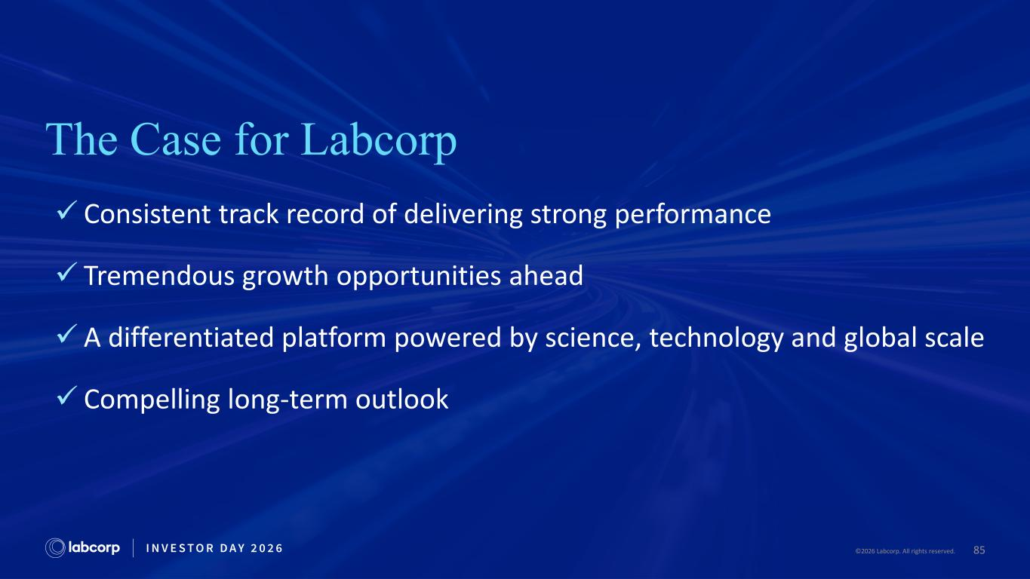
85©2026 Labcorp. All rights reserved. The Case for Labcorp ✓ Consistent track record of delivering strong performance ✓ Tremendous growth opportunities ahead ✓ A differentiated platform powered by science, technology and global scale ✓ Compelling long-term outlook

©2026 Labcorp. All rights reserved.


©2026 Labcorp. All rights reserved. Appendix

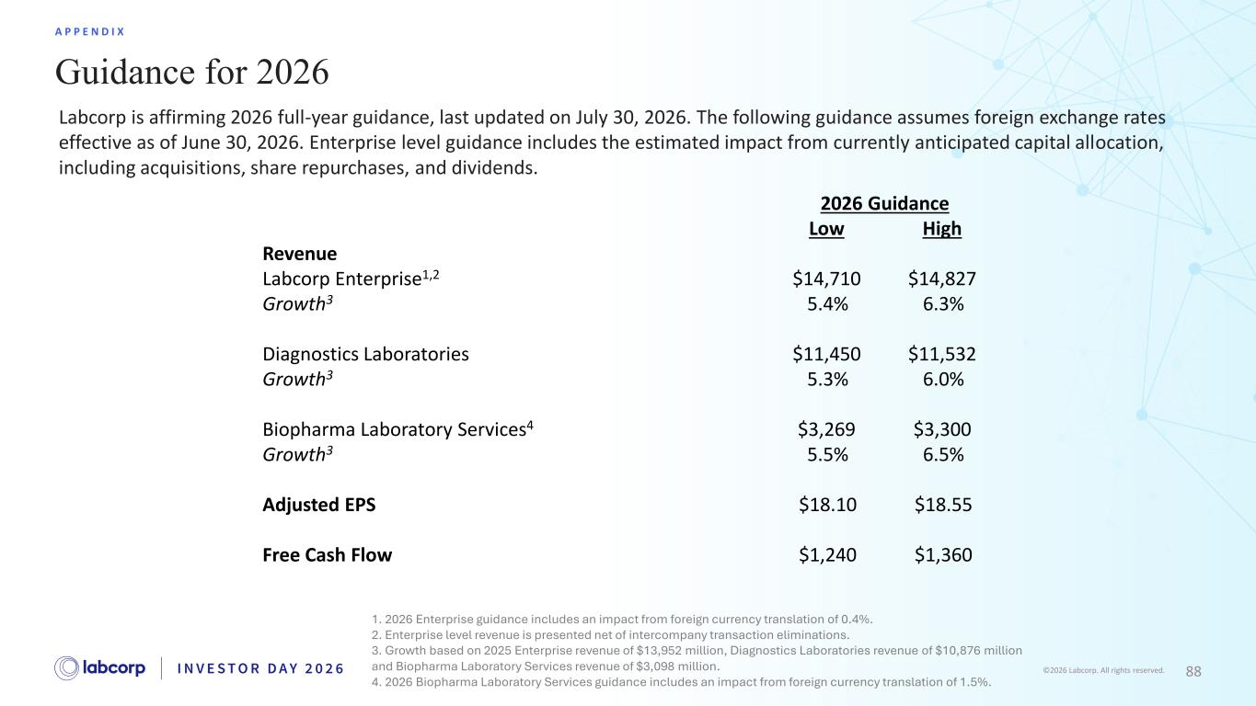
88©2026 Labcorp. All rights reserved. Guidance for 2026 A P P E N D I X 2026 Guidance Low High Revenue Labcorp Enterprise1,2 $14,710 $14,827 Growth3 5.4% 6.3% Diagnostics Laboratories $11,450 $11,532 Growth3 5.3% 6.0% Biopharma Laboratory Services4 $3,269 $3,300 Growth3 5.5% 6.5% Adjusted EPS $18.10 $18.55 Free Cash Flow $1,240 $1,360 1. 2026 Enterprise guidance includes an impact from foreign currency translation of 0.4%. 2. Enterprise level revenue is presented net of intercompany transaction eliminations. 3. Growth based on 2025 Enterprise revenue of $13,952 million, Diagnostics Laboratories revenue of $10,876 million and Biopharma Laboratory Services revenue of $3,098 million. 4. 2026 Biopharma Laboratory Services guidance includes an impact from foreign currency translation of 1.5%. Labcorp is affirming 2026 full-year guidance, last updated on July 30, 2026. The following guidance assumes foreign exchange rates effective as of June 30, 2026. Enterprise level guidance includes the estimated impact from currently anticipated capital allocation, including acquisitions, share repurchases, and dividends.

